User Guide for Natural England’s Priority Habitats’ Inventory version 2.1
15th December 2015

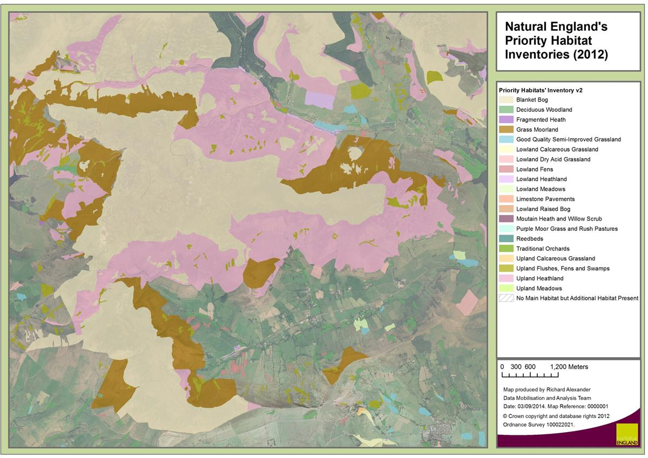

Contents
Introduction 2
Downloading and viewing in GIS 5
Attribution 8
Input datasets 9
Boundaries 13
Rules for identifying main and additional habitats 15
Changes implemented from PHI version 2.0 to 2.1 20
Changes previously implemented from PHI version 1.0 to 2.0 21
Next steps 22
Contacts 22
Glossary of terms 23
Appendix 1. Rules for identifying main and additional candidates 24

Introduction

What is PHI?

Natural England’s Priority Habitats’ Inventory (PHI) is a spatial dataset that describes the geographic extent and location of priority habitats in England. The PHI has been developed to replace twenty-four separate Biodiversity Action Plan (BAP) priority habitat inventories.

Version 2.1 of the PHI replaces v2.0 which was released in 2014 as a beta version and was the first version to be made widely available. This document is designed to provide users with an understanding of how the PHI has been developed, what it shows, and what limitations there are to its use. Natural England is keen to receive feedback from internal and external users on an ongoing basis, and we will feed any comments into the preparation of our next update. See the section on Next Steps for more information.

The core objective for the new PHI was simplification, through the consolidation of the existing separate inventories into a new single spatial layer. This has enabled us to:

- Address 280,000ha of overlap within the existing inventories, by identifying one main habitat per polygon, whilst ensuring evidence for the presence of additional habitats is also included in the attribution.
- Improve consistency with other data sources, in particular by drawing on evidence from Natural England’s SSSI (ENSIS) and Environmental Stewardship (Genesis) databases.
- Produce a dataset which can be updated more easily and regularly in future, by only having to edit one layer when incorporating new data.

The production of PHI has involved the adoption of a common spatial framework based on OS MasterMap (OSMM). Each OSMM polygon has been attributed with data from the key input datasets. The ‘candidate’ data are then evaluated within a common framework using a set of automated rules, as below.

Priority Habitats’ Inventory
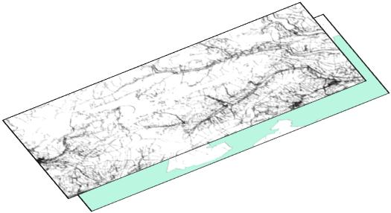
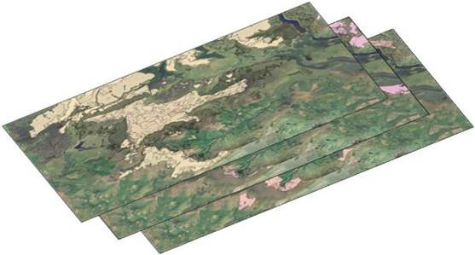
24 Individual inventories
OSMM Base mapping

Rules

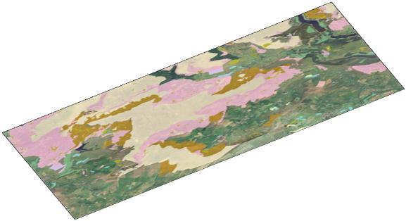

HLS data
SSSI data

PHI
PHI’s core underpinning data is derived from the 24 separate habitat inventories, a combination of national and local datasets collated since 1999. The survey data itself originates from the 1970s onwards, with, exceptionally, a few examples of older data; the most recent records are from 2015. These original habitat inventories were known to have gaps, including for some high value habitats. In producing the PHI, we have therefore drawn on additional data held within the ENSIS and Genesis databases. These are described in more detail later.

The automated rules drive the output of PHI. The rules result in each polygon being attributed with a main habitat and information on the sources from which it has been mapped. Polygons may contain more than one priority habitat and so additional habitats are attributed where data indicates they may be present within a broader habitat mosaic. When using PHI to estimate the extent of habitats, it is recommended that only the main habitat field is used. The additional habitats field may be used to investigate the distribution of smaller features, but as these habitats have not been mapped it should not be used for calculating their extent.

What does PHI v2.1 include?

PHI maps habitats of principal importance for biodiversity in England. These were previously known as Biodiversity Action Plan priority habitats. The following priority habitats are included in PHI:

Habitat | Abbreviation
Blanket bog | BLBOG
Calaminarian grassland | CALAM
Coastal & floodplain grazing marsh | CFPGM
Coastal sand dunes | CSDUN
Coastal vegetated shingle | CVSHI
Deciduous woodland | DWOOD
Limestone pavements | LPAVE
Lowland calcareous grassland | LCGRA
Lowland dry acid grassland | LDAGR
Lowland fens | LFENS
Lowland heathland | LHEAT
Lowland meadows | LMEAD
Lowland raised bog | LRBOG
Maritime cliff & slope | MCSLP
Mountain heath & willow scrub | MHWSC
Mudflats | MUDFL
Purple moor grass & rush pastures | PMGRP
Reedbeds | RBEDS
Saline lagoons | SLAGO
Coastal saltmarsh | SALTM
Traditional orchards | TORCH
Upland calcareous grassland | UCGRA
Upland hay meadows | UHMEA
Upland heathland | UHEAT
Upland flushes, fens & swamps | UFFSW

Marine and freshwater habitats are not currently included, nor are Arable field margins, Hedgerows, Inland rock and scree habitats. Some other habitats, such as Open mosaic habitats on previously developed land and Wood-pasture and parkland are also not included in PHI, but have their own separate inventories.

The individual woodland priority habitat types are not mapped separately in PHI, but are included en bloc within the broader Deciduous woodland habitat. Where it is available, additional information on the presence of the individual priority woodland types listed below is included in the attribution for individual polygons.

- Lowland beech and yew woodland
- Lowland mixed deciduous woodland
- Upland mixed ashwoods
- Upland oakwood
- Wet woodland

PHI includes information on selected non-priority habitats which are mapped where information indicates this to be the main habitat present rather than a priority habitat type. In the case of grass moorland and fragmented heath this is typically because priority habitats may be present within a matrix of other semi-natural non priority habitat, whilst good quality semi-improved grassland has been included because it may have restoration potential and/or be making an important contribution to ecological networks. It should be noted that the mapping of these habitats in PHI is still not comprehensive.

Habitat | Abbreviation
Fragmented heath | FHEAT
Grass Moorland | GMOOR
Good quality semi-improved grassland | GQSIG

In some cases, a priority habitat may be present within a polygon, but its extent may be less than the minimum mapping unit, and will not have been mapped separately. In such cases a polygon may be attributed as no main habitat, but with the priority habitat attributed as additional habitat only.

The PHI represents the best available information on priority habitats at an England-wide level; it is not and will never be a definitive dataset for priority habitats across England. Users of PHI should take into account:

- For parts of the country, or for specific habitats, there may be more recent or better quality data available, such as held by local partners, which Natural England has either not had access to or permission to publish. We also still hold datasets that have not yet been processed for inclusion in the PHI and which will be included in future updates.
- The quality of the inventory is variable: some polygons are derived from recent survey with habitat boundaries mapped accurately and high confidence in the determination of the habitat. However, for other polygons the information available may be insufficient to confidently confirm the presence of priority habitats.
- In some cases habitats may not have been mapped in the original data, such as where the original inventory polygons originate from a point dataset, database or from local wildlife site citations (see Table 2 and Table 4 for information on sources), so the site boundary or land parcel has been used as a proxy for the extent of the habitat.

As such it should be recognised that the PHI provides a generalised map of the priority habitats in an area, when compared to the detail of a National Vegetation Classification (NVC) survey for example.

Downloading and viewing in GIS
The Priority Habitats’ Inventory is published in the following formats:

- ESRI shapefiles
- MapInfo tables
- GML
The files can be downloaded from the geographic data link on Natural England’s website. They are also available to download from the Environment Agency’s Geostore website. The PHI is also available to view on the MAGIC website.

Depending on the download site, the layer will have been split into multiple parts to reduce the size of the individual download files. You may therefore need to download more than one file to cover the area you are interested in. Figure 1 shows how the download files for v2.0 were divided on the two download sites. Along the edge of the squares, polygons have not been split but assigned to one of the download files on the basis of their centroid.

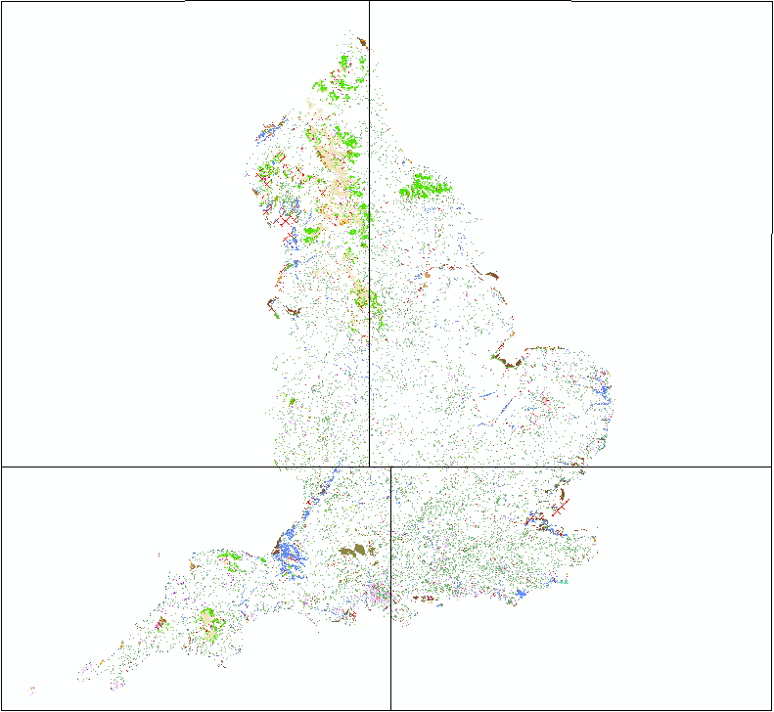 | 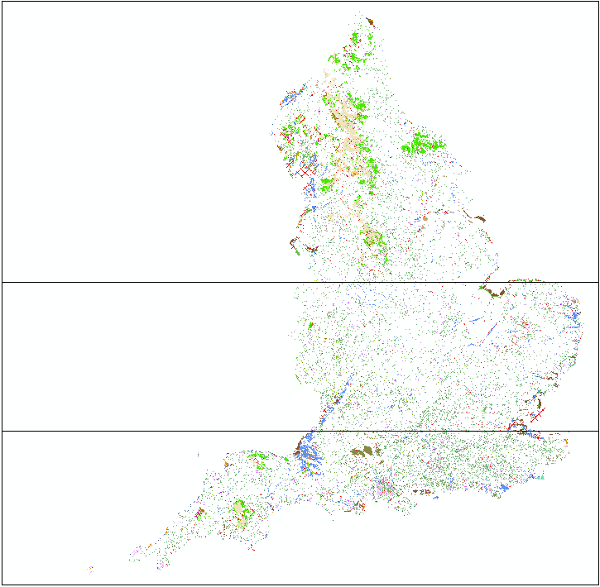
Figure 1: Shows the separated download areas for Natural England’s website (left) and the Geostore website (right).

Once the dataset has been downloaded and unzipped the files can be opened using GIS software. Depending on the format downloaded, the files may be viewed in software such as ArcGIS, MapInfo, or Quantum GIS.

If using ArcGIS, you should download the shapefile version. The download file includes a layer file containing the default colours for displaying the Priority Habitats’ Inventory. In ArcMap add the layer file, e.g. PHI National.lyr, to the map using the Add Data button. The map will not initially display and a red exclamation mark will appear next to the layer name.

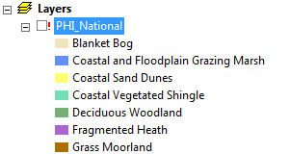

To display the map you need to locate the shapefile. Right click on the layer name (e.g. PHI_National) in the Layers’ window and select Properties from the drop down menu.

In the Layer Properties dialog click on the Source tab at the top. Now click on the Set Data Source button and select the location of the shapefile you downloaded.

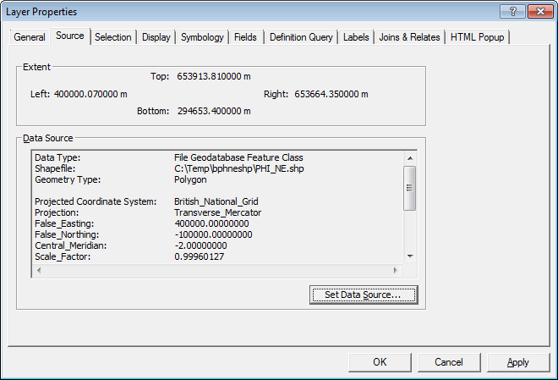

Click on OK to close the Layer Properties window. The Priority Habitats’ Inventory polygons should now display in the standard colours.

In order to retain the location of the shapefile, right click again on the layer name (e.g. PHI National) in the Layers’ window and select Save As Layer File. You can overwrite the existing layer file.
To specify the symbology for the shapefile yourself, instead of adding the layer file add the shapefile directly to the map using the Add Data button. Right click on the layer name and select Properties.

In the Symbology tab under Show expand Categories and select Unique values. Under Value Field select Main_Habit and click on Add All Values. You can now specify your own colours etc. for each habitat.
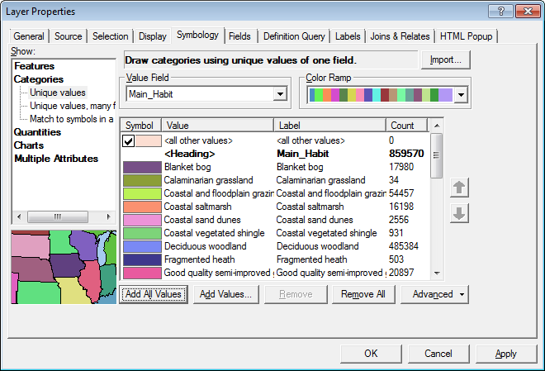.

Figure 2 shows the Priority Habitats’ Inventory in ArcGIS once the symbology has been selected for the main habitat field. The map shows moorland areas with blanket bog, upland heathland and grass moorland surrounded by a landscape with patches of good quality semi-improved grassland, lowland heathland, deciduous woodland and upland hay meadows.

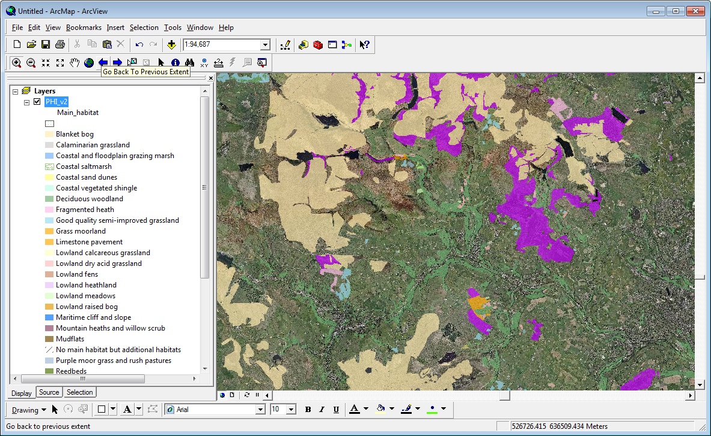
Figure 2: Priority Habitats' Inventory version 2.0 beta in ArcMap

Attribution

The attribution provides supporting evidence for the mapping within each polygon, and an audit trail explaining how the rules have driven the outcome. The following attributes are included for each PHI polygon:

Field name | Description | Example
Main_habitat | Main habitat identified for the polygon | Coastal sand dunes
Confidence | Inventory with NVC data less than 5 years old: High  Inventory with NVC data more than 5 years old: Medium  Inventory less than 10 years old without NVC data: Medium  Inventory with corresponding HLS options: Medium  All other polygons: Low | Medium
Each polygon may have up to three sources for the main habitat which are attributed in the following priority:

- Inventory sources
- FEP + HLS sources
- Aerial photography
- ENSIS features
- Base mapping
Source1 | Name of source | Sand Dune Vegetation Survey of Great Britain
S1Date | Reference date of source | 01/03/1989
S1Habclass | Habitat classification of the source | National Vegetation Classification
S1HabType | Habitat type of the source | SD8b SD7a SD6e SD6b SD8a SD9b SD10
Source2 | As for source 1 | Higher Level Stewardship
S2Date | As for source 1 | 01/05/2007
S2Habclass | As for source 1 | FEP/HLS features and options
S2HabType | As for source 1 | C02: Coastal sand dunes; HP2
Source3 | As for source 1 | Natural England's SSSI database (ENSIS)
S3Date | As for source 1
S3Habclass | As for source 1 | SSSI habitat features
S3HabType | As for source 1 | Sand dune; strandline, embryo and mobile dunes; SD1-6
BaseMapping | The base map scale | 1:10000
Annex_1 | EU Habitats Directive (1992) Annex 1 habitats attributed based on correspondence with NVC data or where attributed in the inventories | Shifting dunes with marram (H2120), Shifting dunes (H2110), Dune grassland (H2130)
Add_habitats | Additional habitats that may be present, but that were not identified as the main habitat for the polygon | SSSI features: CG7
Candidates | Habitats identified as candidates for main or additional habitats. | Main habitat: CSDUN (PHI > 50%, ENSIS L1, FEP + HLS); Additional: LCGRA (ENSIS L2); MUDFL (ENSIS L2)
Rule_Decis | Outcome of rules used to separate candidates for main or additional habitats | Tests failed: A1.MasterMap description (MUDFL)
General_Comment | Determination comment for main habitat from the original habitat inventory. | Habitats occur as a mosaic and are very closely associated. Landline is not detailed enough to separate habitats on landward side.
LastModDate | Polygon last modified date (including for manual updates) | 03/07/2014
ModReason | Reason for last modification for manual changes. | Maritime cliffs checked against AP
URN | Unique reference number for the PHI polygon (centroid) | NY 99814 28591
Table 1: Example of habitat polygon attribution in PHIv2

Input datasets
The following national habitat inventories have fed into the Priority Habitats’ Inventory:

Habitat inventory | Published | Sources
Coastal sand dunes | 2004 | Based on the original paper inventory Sand Dune Vegetation Survey of Great Britain – Part 1 England; Radley G.P. 1994, and is a collation of survey data, the majority carried out between 1987 and 1990.
Coastal vegetated shingle | 2009 | Ferry and Waters (1985), Dungeness: Ecology & Conservation  Ferry, Lodge and Waters (1990), Dungeness: A vegetation survey of a shingle beach  Sneddon and Randall (1993), Coastal Vegetated Shingle Structures of Great Britain: Main Report  Sneddon and Randall, (1994), Coastal Vegetated shingle structures of Great Britain: Appendix 3: Shingle sites in England  Williams and Cooke (1993), Vegetated shingle survey of the Sussex coast  Antonini and Bennat (1996) Title unknown (Pagham Harbour) including maps by Fuller (1989)  Young-Husband (2003), Environmental Monitoring of Vegetated Shingle Habitats in East Sussex
Maritime cliff and slope | 2008 | National Maritime Cliff Database, Natural England’s ENSIS database, Ordnance Survey Landline and Environment Agency LIDAR data (< 1%).
Mudflats | 2004 | Environment Agency R&D Technical Report E2A: Biodiversity Key Resources Inventory (2002) and Ordnance Survey MasterMap and OS 10k Raster land maps.
Saline lagoons | 2003 | Primary source: A directory of saline lagoons and lagoon like habitats in England (Smith B.P. and Laffoley D.) 1992.
Lowland calcareous grassland | 2009 | The original grassland inventories were produced during the mid 1990s to document the known localities of good quality species rich lowland grassland of nature conservation value in each English county. These inventories highlighted only those grassland sites for which English Nature, or other organisations, held detailed survey information at the time of their publication.  In 2004 English Nature published priority lowland grassland inventories, following re-interpretation of the original survey data, in light of priority grassland definitions and improved digitisation of site boundaries.  The inventories were updated during a two year project between 2005-07 which aimed to utilise recently collected grassland survey data of the requisite quality to update the inventories region by region. Survey data was sourced from a large number of sources including local authorities, wildlife trusts, local record centres, National Trust, English Nature, Defra/RDS, Forestry Commission, National Parks, utility companies and natural history societies.
Lowland dry acid grassland | 2009
Lowland meadows | 2009
Purple moor grass & rush pastures | 2009
Undetermined grassland | 2009
Upland hay meadows | 2009
Calaminarian grassland | 2013 | The original work on calaminarian grassland was published by NCC in 1988. These data were then brought together with a number of more recent sources including SSSI and agri-environment scheme data and more recent local and national survey to produce a digitised dataset that was produced for Natural England in 2013,
Lowland heathland | 2011 | The original paper lowland heathland inventory was produced in 1994 by English Nature and RSPB, and is a collation of survey data, the majority carried out between 1985 and 1994. An initial digitised inventory was published in 2004 and also incorporated outputs from the National Biodiversity Network South West pilot.  The inventory has been updated through a series of regional contracts with local record centres and other contractors, with data captured between 2006 and 2011. This data originates from Phase 1 surveys, local wildlife site and SSSI files and aerial photography interpretation.
Traditional orchards | 2012 | Derived using aerial photography, Ordnance Survey MasterMap, external datasets compiled from historic surveys, and ground truthing.
Limestone pavements | 2011 | The data for Yorkshire and Cumbria is derived from the digitisation of 1:10,000 paper maps relating to Limestone Pavement Orders and mapping of habitats on SSSIs. Where this information was not available then pavement boundaries were digitised from aerial photographs.  Data for Yorkshire were captured primarily from a baseline National Vegetation Classification (NVC) survey of the Ingleborough Complex SAC and Craven Limestone Complex SAC commissioned as part of the EU-LIFE funded Limestone Country Project.
Blanket bog | 2012 | The datasets originally used to create the original inventory were Land Cover Map 2000, ENSIS (English Nature Site Information System) and local English Nature teams digital NVC surveys.  Additional digital NVC Surveys were then incorporated (Cumbria, North Pennines, Skiddaw, Mill House, Squallcombe, Pinkworthy/Chains/Haddon Hill, Warren Farm, Holincote Moorland, Armboth, Leek Moors, Bowland Estate)  Other datasets included:  Long Mynd habitat map  National Biodiversity Network South West Pilot Data  Biological Survey of Common Land.  The Soilscapes dataset was used to create a blanket bog layer outside of the "known" areas (SSSIs and Bodmin common lands).
Upland calcareous grassland | 2008 | The datasets originally used to create the inventory were Land Cover Map 2000, ENSIS (English Nature Site Information System) and local English Nature teams’ and digital NVC surveys (Cumbria, North Penines, Skiddaw) and National Trust East Midlands 2002-04, Biological Survey of Common Land 1987-99.  The Soilscapes dataset was used to help in eliminating areas of "Upland Calcareous Grassland" identified by LCM 2000 where the underlying soil type indicated that these were unlikely.
Upland heathland |  | The datasets used to create the inventory were:  Land Cover Map 2000  ENSIS (English Nature Site Information System)  Digital NVC surveys (Cumbria, North Pennines, Skiddaw, Mill House, Pinkworthy/Chains/Haddon Hill, Warren Farm and Holincote Moorland);  National Trust East Midlands Upland BAP Survey 2002-04,  Forest of Bowland 2000 survey (United Utilities),  Haweswater 2003 (United Utilities survey);  Stiperstone 2002 (Shropshire County Council)  Armboth NVC survey (United Utilities)  Leek Moors NVC survey  Long Mynd Habitat Map  National Biodiversity Network South West Pilot Data;  Biological Survey of Common Land;  Ordnance Survey MasterMap Data - Heath Extract.  The Soilscapes dataset was used to help distinguish between "Acid Grassland – heath content unknown" and "Upland heathland" identified by LCM 2000 where the underlying soil type indicated that these were unlikely.
Coastal & floodplain grazing marsh | 2012 | The data is based mainly on a GIS polygon layer that represents an inventory of Lowland Wet Grassland in England, Dargie (1993). Ordnance Survey (OS) Profile elevation data and OS 10K raster basemaps were also utilised. Through interrogating the OS elevation data to find areas of low slope which were intersected by drainage network (extracted from the OS 10K rasters), a ‘wet area’ was produced. A coincidence of lowland wet grassland polygon and ‘wet area’ polygon was considered to have a high expectation of being CFPGM habitat.  The inventory has been updated through a series of regional contracts with local record centres, with data captured between 2005 and 2010. This data originates from Phase 1 habitat surveys, Farm Environment Plans, local wildlife site surveys and aerial photography interpretation.
Fens | 2011 | The dataset was originally based on FenBASE, a point based inventory of fen habitat location, supplied by Natural England. A detailed polygon coverage of the West Midlands and Lancashire was also available from a pilot study commissioned by Natural England.  The inventory has been updated through a series of regional contracts with local record centres and other contractors, with data captured between 2005 and 2010. The sources include a range of NVC and Phase 1 surveys as well as local wildlife sites and sites of special scientific interest data.
Lowland raised bog | 2004 | The data is based mainly on BogBASE, a point based inventory of Lowland Raised Bog habitat location, ENSIS (English Nature Site Information System) and the England Inventory for the Wetland Habitat Action Plan: Pilot Project.
Reedbeds | 2012 | The dataset was originally based mainly on RSPB Reedbed Inventory, a point based inventory of Reedbed habitat location.  A detailed polygon coverage of the West Midlands and Lancashire was also available from a pilot study commissioned by English Nature, and the relevant reedbed habitat polygons were lifted directly from this and placed into the new inventory layer.  The inventory has been updated through a series of regional contracts with local record centres and other contractors, with data captured between 2004 and 2011.
Deciduous woodland | 2013 | Extracted from Forestry Commission’s National Forest Inventory. The following categories were used to identify deciduous woodland: Broadleaved (B), Mixed (Mb) - predominantly broadleaved, Coppice (O), Coppice-with-Standards (P).
Coastal saltmarsh | 2012 | The Environment Agency’s Saltmarsh Extents dataset has also been used as an input dataset in this version.
Table 2: Original habitat inventories inputting to the Priority Habitats’ Inventory

The following additional datasets were incorporated into the corresponding inventory prior to processing.

Alkaline Fens & Transition Mire Inventory
East Midlands PDNPA lowland meadows survey data
Peak District Dales Alkaline Fens SAC 2003
North West Grasslands Validation survey 2010
North Pennines AONB Haytime data
Missing data from Traditional Orchards Inventory
Updated Calaminarian Grassland Dataset 2013
Table 3: Additional habitat datasets incorporated into the Priority Habitats' Inventory

The following core datasets also fed into the production of the Priority Habitats Inventory:

Name | Reference date | Description
Ordnance Survey MasterMap® (OSMM) | August 2013 | Topographic area polygons have been used as the underpinning mapping framework.  MasterMap descriptive terms were used to help to separate broad land cover types.
Sites of Special Scientific Interest unit boundaries.  Natural England’s SSSI database (ENSIS) | September 2014  June 2014 | Data was extracted from Natural England’s former SSSI database (ENSIS) and attributed against the SSSI units. Information for each unit included main habitat, description, features and NVC codes.
Rural Land Registry parcels  Environmental Stewardship Farm Environment Plan features’ data and Higher Level Stewardship options data | September 2014  April 2015 | Higher Level Stewardship (HLS) Farm Environment Plan (FEP) features and corresponding HLS management options were attributed against individual RLR (Rural Land Registry) parcels. FEP paper maps were not used.
Moorland boundary | June 2010 | Used to separate between upland and lowland habitats
Aerial photography | 1999 to 2009 | Aerial photography has been used during the testing and refinement of the rules and to support manual changes.
Table 4: Other datasets feeding into the Priority Habitats’ Inventory

Boundaries
In version 1.0 of the Priority Habitats’ Inventory, OS MasterMap polygons were used as the framework for attributing habitats. MasterMap was chosen as it provided the finest scaling of mapping of all the alternatives considered. Rural Land Registry parcel boundaries were excluded because they do not cover all areas of semi-natural habitats. Land Cover Map polygons were considered, but the boundaries were found to be too generalised.

Unfortunately, MasterMap polygons do not universally fit well to habitat parcels, with particular issues identified for some of the upland and coastal habitats. Figure 3 shows an area of coastal saltmarsh, as mapped in the Environment Agency’s saltmarsh extents inventory. The MasterMap polygons do not separately map this area.

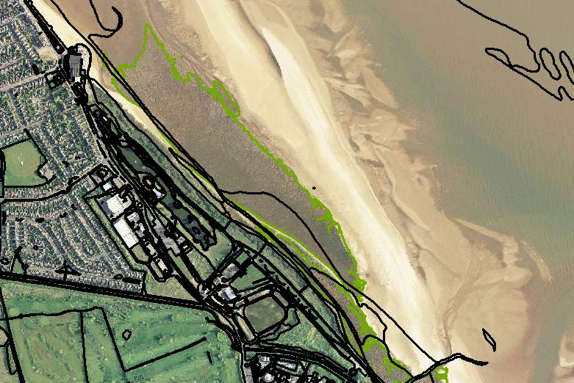
Figure 3: MasterMap topographic area polygons shown in black (excludes built-up areas) and Environment Agency saltmarsh extents boundary shown in green

To address such problems, for v2.0 MasterMap polygons were split against the original habitat inventories where there was a poor fit to the inventory polygon, except where this would create a new polygon below the minimum mapping unit (0.25ha). A poor fit was determined where difference in the area of an inventory polygon to the area of the underlying MasterMap polygons was greater than 10% (see Figure 4). Subsequently, for PHI v2.1 MasterMap polygons have also been split against SSSI unit boundaries and Rural Land Registry parcels and the minimum mapping unit reduced to 0.1ha.

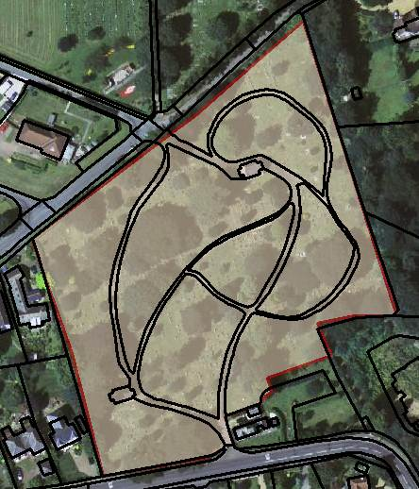 | 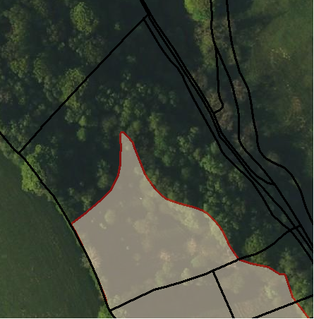
Figure 4: Left image shows an inventory polygon (red lines) with a good fit to the underlying MasterMap polygons (black lines) and the image on the right shows an inventory polygon with a poor fit.

In the following example (Figure 5), the MasterMap polygons have been split against the upland inventories. The blue lines show the new polygons created as a result of splitting. Without splitting of the MasterMap polygons much of the detailed digitising from the original surveys would have been lost. The red lines shows the line work excluded, either if they would create new polygons below the minimum mapping unit or because one or more MasterMap polygon already provide a close fit to the original inventory polygon.

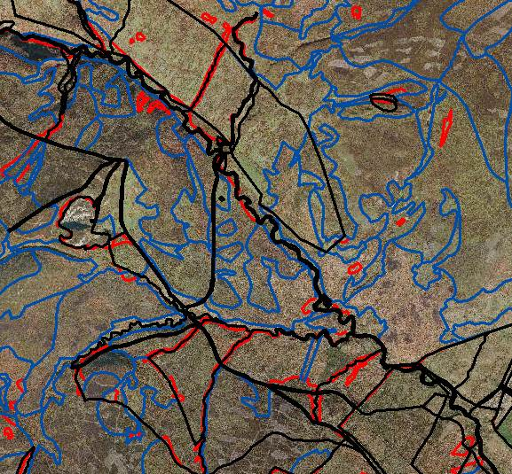
Figure 5: Splitting of OS MasterMap polygons against upland inventory polygons. Black lines are the MasterMap polygons, blue lines show the polygons after splitting and the red inventory lines have been excluded because they would result in new polygons below the minimum mapping unit.

The benefits of splitting mean that the original detailed mapping in the original inventories is not lost where MasterMap polygons do not provide this level of detail. The risk of splitting is that poor quality digitising derived from the original inventories will perpetuate into the Priority Habitats’ Inventory.

For the coastal and floodplain grazing marsh inventory, adjoining polygons were first merged prior to splitting due to the presence of arbitrary polygon boundaries.

Rules for identifying main and additional habitats
For each PHI polygon (MasterMap or split MasterMap polygon) a series of automated rules were applied on the input data.

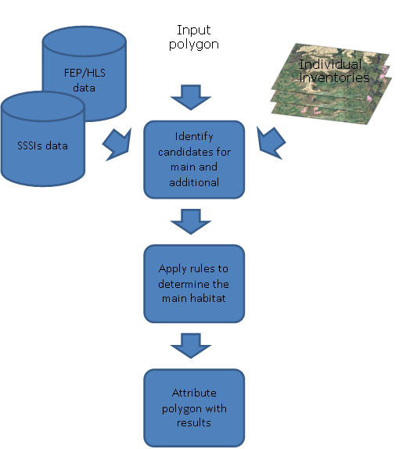
Figure 6 Process for identifying priority habitats in the PHI.

Identifying candidates for main habitat

The rules for determining the main habitat for each PHI polygon work by first identifying candidates meeting the specified criteria, based on the input datasets. (See Appendix 1, section 1 for more details).

For habitat inventories, the inventory polygon must cover at least half of the PHI polygon for it to be considered as a candidate for the main habitat.

For SSSIs, each SSSI unit is attributed with a level 1 feature (describing the main habitat) and one or more level 2 features. There is a good correlation between level 2 features and priority habitats (See Appendix 1, Table A2). However, level 2 features may only represent a relatively small feature within a larger SSSI unit. Therefore, the relationship between the level 1 feature description and the level 2 feature name has been used to determine whether the level 2 feature may be a candidate for the main habitat. (See Appendix 1, Table A1)

For example, the level 2 feature, “Lowland neutral grassland (MG5)” if matched against the level 1 description and name: GRASSLAND: NEUTRAL, UNIMPROVED and MESOTROPHIC GRASSLAND would be a candidate for the main habitat. However, if the level 1 description is “SEMI-IMPROVED NEUTRAL GRASSLAND” and the level 2 feature “Lowland neutral grassland (MG5)” then this would not be a candidate for the main habitat.

For Higher Level Stewardship data, the Farm Environment Plan (FEP) features are considered as candidates for the main habitat if there are corresponding management options (See Appendix 1, Table A4). For example, M06 Blanket bog must be under one the following options to be considered as a main candidate:

HL7 Maintenance of rough grazing for birds
HL8 Restoration of rough grazing for birds
HL9 Maintenance of moorland
HL10 Restoration of moorland

In addition to the presence of corresponding HLS options, the FEP features’ area must be equivalent to at least half of the PHI polygon. This is calculated based on the ratio of the feature quantity to the Rural Land Registry parcel area and the proportion of the RLR parcel intersecting the PHI polygon.

Elimination of main candidates

Once candidates for the main habitat have been identified, a series of tests are then applied.

The first test checks whether the habitat is incompatible with the MasterMap description (tests 1. and 1b. MasterMap description). For example, if the MasterMap description is ‘Tidal Water’ then all terrestrial habitats will be rejected.

For lowland meadows and upland hay meadows, a high proportion of the habitat mapped in the original inventories is now unlikely to be of priority habitat quality. Therefore, unless corresponding NVC data are present, or the land is under the HLS option, HK6 (Maintenance of species-rich, semi-natural grassland), the habitat is considered to be good quality semi-improved grassland (test 1d. NVC/HLS options).

Where a PHI polygon is covered in at least 50% coniferous woodland, based on the NFI layer, then any candidates will only be attributed as additional habitats (test 2. Coniferous woodland).

Finally, the moorland boundary is used to separate between upland and lowland habitats (test 3. Moorland boundary). Where there is a corresponding habitat, e.g. Lowland calcareous grassland and Upland calcareous grassland, then the candidate is changed to its upland/lowland equivalent, based on whether at least half of the PHI polygon intersects the moorland boundary. If there is no equivalent, e.g. Grass moorland below the moorland line, then the habitat is rejected. In some cases unenclosed land may contain lowland habitats, e.g. in the Derbyshire Dales. Therefore, where only lowland grassland communities are present above the moorland line, the lowland habitats will be retained.

(See Appendix 1 section 2 for more details).

Separation of main candidates

Once the above tests have been completed then there will either be no main candidates remaining, one, or more than one. If there is only one candidate remaining then this can be attributed as the main habitat. If there is more than one then a series of tests are run until only one candidate is left. If all of the remaining candidates fail a test then the result is not applied.

The first separation test, 4. Max number of sources, tests whether the three sources (inventory, FEP and ENSIS data) all correspond, e.g. the blanket bog inventory maps the area as blanket bog and there are also SSSI and FEP blanket bog data present, in which case it will be attributed as the main habitat.

Test, 5. Definitely is, uses the original habitat inventory ‘priority habitat determination’ (PRIDET) field to identify polygons that have high confidence. Additional criteria are also applied on the source fields to ensure that the inventory polygon is reliable.

NVC data are used to separate between candidates for lowland grassland types (test 6. NVC type). Habitats with corresponding NVC data present (See Appendix 1, Table A3 and A8) will be prioritised over habitats without, e.g. Purple moor grass and rush pasture with corresponding NVC data (M22 to M26) will be prioritised over Coastal and floodplain grazing marsh (where no NVC types have been associated with it).

If there is still more than one candidate then candidates with inventory polygons where the attribution indicates low confidence are rejected. For example, if the determination comment includes terms such as “data insufficient”, or the interpretation quality is “poor” then the habitat will be rejected, except if there is supporting FEP or ENSIS data (test 7. Inventory confidence).

Next the MasterMap descriptive terms are used, this time to separate between two or more habitats (test 8. MasterMap description). For example, if the MasterMap description is ‘Rough grassland’ then Lowland dry acid grassland would be favoured over Deciduous woodland. Nb. The MasterMap descriptive terms are quite broad so the association of habitats with each term is generally inclusive (see Appendix 1 Table A6).

Where an inventory polygon is no more than twice the size of the largest PHI polygon it intersects and is not considered to be of low confidence then it will be prioritised as the main habitat. In PHI v2.1 the test (9. Inv fit) now applies to the whole inventory polygon so long as it is the smallest inventory polygon intersecting the PHI polygon.

Finally, if there is still more than one candidate remaining after the above tests then any candidates based on inventory sources are prioritised over FEP and ENSIS sources (tests 10a-c Source confidence). Individual habitats are also prioritised, so Deciduous woodland would be mapped over Lowland heathland at this stage (see Appendix 1 Tables A9 and A10).

(See Appendix 1 section 3 for more details)

Outputs

Once the rules have completed, each PHI polygon may be assigned a main habitat from the list below. The list includes twenty five priority habitats and three non-priority habitats.

The non-priority habitats (Good quality semi-improved grassland, Fragmented heath and Grass moorland) may also be output as a main habitat. They have been included primarily because of their potential to contribute to broader ecological networks, either through active restoration to priority habitat or through the function they may play in linking areas of higher quality habitat.

Where all habitats present are of lower confidence, or cannot be accurately mapped, then a PHI polygon may not be assigned a main habitat and will be attributed as ‘no main habitat but additional habitats’. Above the moorland line polygons with only additional habitats will have their main habitat attributed as ‘Grass moorland’.

Habitat
Blanket bog
Calaminarian grassland
Coastal & floodplain grazing marsh
Coastal sand dunes
Coastal vegetated shingle
Deciduous woodland
Fragmented heath²
Grass Moorland²
Good quality semi-improved grassland²
Limestone pavements
Lowland calcareous grassland
Lowland dry acid grassland
Lowland fens
Lowland heathland
Lowland meadows
Lowland raised bog
Maritime cliff & slope
Mountain heath & willow scrub
Mudflats
Purple moor grass & rush pastures
Reedbeds
Saline lagoons
Coastal saltmarsh
Traditional orchards
Upland calcareous grassland
Upland hay meadows
Upland heathland
Upland flushes, fens & swamps
²Not a priority habitat

Additional habitats

Once the main candidate has been identified then any candidates that were rejected will be considered for attributing as additional habitats. In addition, any inventory polygons covering less than half of the PHI polygon but more than 0.25ha, or where at least half the polygon is within the PHI polygon will be considered for additional candidates. In PHI v2.1 additional candidates must also intersect at least 10% of the PHI polygon. FEP and SSSI features not meeting the criteria for main candidates will also be considered for additional habitats.

The only tests applied to additional candidates are that they are not incompatible with the MasterMap descriptive term for the polygon and the moorland boundary test.

(See Appendix 1 sections 4 and 5 for more details)

Manual changes

Manual changes have been made to 9,697 polygons comprising 12,089 ha. These were primarily:
- Separation of Upland and Lowland heathland, based on the Severely Disadvantaged Area boundary and contour data. The SDA boundary was used as the moorland boundary includes areas of unenclosed land, particularly in south west England, well below 250m.
- Checking of Maritime cliffs and slope areas against aerial photography and contour data.
- Incorporating new data from Natural England advisers’ field visits.

Changes implemented from PHI version 2.0 to 2.1

The production of PHI is an iterative process involving ongoing refinements that are designed to improve the quality of the output. The changes described below are additional to those implemented between v1.0 and 2.0 which are described in the subsequent section of the user guide.

Boundary framework
- MasterMap polygons are now split against SSSI and RLR parcels as well as inventory polygons
- MasterMap polygons are now split against (a dissolved version) of the coastal and floodplain grazing marsh inventory
- The threshold for dissolving newly created polygons has been reduced from below 0.25ha to below 0.1ha.

Candidates
- SSSI level 2 features for Habitats Directive Annex 1 habitats are now associated with corresponding priority habitats
- Additional candidate polygons must now intersect at least 10% of the PHI polygon, as well as the intersect area being at least 0.25ha or more than half the inventory polygon intersecting the PHI polygon.
- NVC types are now extracted from the PRIDETCOM field of inventory polygons.
- Upland Fens, Flushes and Swamps can no longer become main candidates on the basis of ENSIS data.

Changes to interpretation of habitat inventory attribution:
- ‘Definitely is this habitat’ etc. now recognised as well as ‘Definitely is’
- ‘England Nature Site Information’ now recognised as ENSIS source.
- ‘Aerial Photos’ now recognised as being an aerial photography source.
- ‘FEP’ now recognised as being a FEP/HLS source.

Rules
- Aerial photography now accepted as a reliable source for limestone pavement for the ‘Definitely is’ test.
- Fit test rule now applies to the whole inventory polygon, provided that it is no larger than twice the size of the largest PHI polygon, not of low confidence and is the smallest intersecting inventory polygon. Equivalent tests for SSSI and HLS polygons has been removed. The test has been moved to after the MasterMap description test.
- Inventory confidence test no longer rejects candidates that also have ENSIS/FEP sources for main habitat.
- Lowland heathland is now prioritised over deciduous woodland for the ‘Source confidence’ rule.

Attribution
- PHI polygons in the uplands are now attributed as ‘Grass moorland’ rather than ‘No main habitat but additional habitats present’ if above the moorland line.
- Confidence attribution now takes account of the age of the inventory source.

MasterMap descriptions
- Traditional orchards are no longer attributed as additional for the MasterMap description ‘Multi-surface’
- Lowland meadows candidates no longer become additional for ‘Multi-surface’ if the inventory polygon is no more than twice the size of the PHI polygon.
- Coastal sand dunes are now associated with the MasterMap description ‘Rough grassland’
- Calaminarian grassland now fails for the same MasterMap descriptions as the other lowland grassland types.

Upland/lowland equivalents
- Upland hay meadow, lowland meadows and coastal and floodplain grazing marsh above the moorland line are now attributed as grass moorland.
- Reedbeds and purple moor grass and rush pasture candidates above the moorland line are converted to upland flushes, fens and swamps.
- Blanket bog candidates below the moorland line are no longer rejected.
- When candidates are changed to their upland/lowland equivalent, attribution of the original sources are now merged.
- The test for lowland grassland NVC communities above the moorland line now ignores the presence of grass moorland candidates.
- Upland habitats with no equivalent below the moorland line are now attributed as additional habitats.

Bug Fixes:
- Now checks for a 50% intersection between the SSSI boundary and the PHI polygon for ENSIS L1 main habitat.
- Inventory sources correctly flagged where there is more than one source for the same habitat intersecting the same PHI polygon.
- Correctly attributes inventory sources where candidates have been converted to their upland/lowland equivalent.
- Inventory polygons attributed as “Not present but close to definition” no longer become a candidate.

Changes previously implemented from PHI version 1.0 to 2.0

In version 1.0 of the Priority Habitats’ Inventory, Ordnance Survey MasterMap polygons were used as the basic mapping framework. In PHI v2.0, MasterMap polygons were split against the original habitat inventory polygons when this added significantly to the resolution of mapping.

The Priority Habitats’ Inventory uses a series of rules, outlined in the previous sections, to determine the main habitat for each polygon. In PHIv2 the criteria for identifying main habitats was tightened so that the estimated FEP feature area must be equivalent to at least half the PHI polygon, also the SSSI features have been validated against both the level 1 feature name and the level 1 feature description. The reliability of individual habitat inventory polygons is also taken into account.

During the development of PHIv2.0, each proposed rule change was run against the whole national dataset and a sample of the polygons whose main habitat had changed were reviewed. Changes were implemented where they resulted in a statistically significant improvement in the identification of main habitats.

The attribution fields have been updated in version 2 so that they are closer to that of the original inventories, whilst providing an audit trail of how the main habitat has been identified for each polygon.

Next steps

Version 2.1 of the Priority Habitats’ Inventory is being published as a full release, and will now represent the baseline for future iterative improvements to PHI. The current plan is to release an annual update focused primarily on including new or enhanced data, whilst at the same time trying to refine aspects of the existing product. Work is likely to involve:

- Developing a reliable and repeatable process for updates
- Incorporation of new datasets
- Reducing the number of unintended slivers of habitats contained in the dataset
- Exploring how to make better use of remotely sensed data to refine our mapping

Contacts

Please contact the Habitats’ Inventory Project Team at the following email address if you have any questions or feedback regarding the Priority Habitats’ Inventory, or if you have data you would like incorporated into the dataset.

HabitatInventories@naturalengland.org.uk

Any new data submitted should meet the minimum criteria for the inclusion:
- Include attribution referring to the original survey from which the habitat was identified (unless the habitat can be identified from remote sensed data – some coastal habitats, grazing marsh, limestone pavement, woodland)
- Include a date against the survey source.
- Include a specific habitat classification – e.g. Phase 1, NVC, Priority Habitat*, IHS* (*The last two are sometimes used for classifying habitats in the field, but more often for data collation).
- Include the original habitat type e.g. MG8, B21, GC1, Limestone pavement
- Be accurately digitised
Natural England can supply guidance on the formatting of data for submission to PHI

Glossary of terms

BAP Biodiversity Action Plan
ENSIS Natural England’s former SSSI database
FEP Farm Environment Plan
HLS Higher Level Stewardship
NFI National Forest Inventory
NVC National Vegetation Classification
OSMM Ordnance Survey MasterMap
PHI Priority Habitats’ Inventory
PHI polygon MasterMap polygon or split MasterMap polygon
RLR Rural Land Registry
SSSI Site of Special Scientific Interest

Habitats
BLBOG Blanket bog
CALAM Calaminarian grassland
CFPGM Coastal and floodplain grazing marsh
CSDUN Coastal sand dunes
CVSHI Coastal vegetated shingle
DWOOD Deciduous woodland
FHEAT Fragmented heath
GMOOR Grass moorland
GQSIG Good quality semi-improved grassland
LPAVE Limestone pavement
LCGRA Lowland calcareous grassland
LDAGR Lowland dry acid grassland
LFENS Lowland fens
LHEAT Lowland heathland
LMEAD Lowland meadows
LRBOG Lowland raised bog
MCSLP Maritime cliffs and slope
MHWSC Mountain heath and willow scrub
MUDFL Mudflats
PMGRP Purple moor grass and rush pastures
RBEDS Reedbeds
SLAGO Saline lagoons
SALTM Coastal saltmarsh
TORCH Traditional orchards
UCGRA Upland calcareous grasslands
UHMEA Upland hay meadow
UHEAT Upland heathland
UFFSW Upland flushes, fens and swamp

Appendix 1. Rules for identifying main and additional candidates

1. Criteria for identifying candidates for main habitat

Criteria | Comments
PHI > 50%  Original priority habitat inventory polygon intersects at least half of the MasterMap polygon. | Fens are separated into lowland fens and upland flushes, fens and swamps based on the moorland boundary.  Undetermined grassland is considered as good quality semi-improved grassland.  Inventory polygons derived solely from ENSIS (except for maritime cliffs and slope) or FEP data are excluded.
FEP + HLS  FEP features with corresponding HLS options where the estimated FEP area is at least half the MasterMap polygon.  If no FEP data then HLS options may be matched to inventory or ENSIS L2 features.  (See tables A4 and A5) | Estimated FEP area = Feature quantity x intersect area between the MasterMap polygon and the RLR parcel / RLR parcel area.
ENSIS L1  ENSIS L2 feature with corresponding L1 feature/L1 description. SSSI unit with corresponding features must intersect at least half of the PHI polygon.  (See tables A1 to A3). | ENSIS Level 2 features may also be matched to Level 1 features’ upland/lowland equivalents.

2. Elimination rules

Elimination rules apply irrespective of the number of candidates remaining:
Rule | Description
1. MasterMap description | Eliminate candidates incompatible with the MasterMap description or consider for additional habitats only (see Table A6).
1b. MasterMap description | Eliminate deciduous woodland polygons derived from ENSIS/FEP data without a corresponding MasterMap description.
1c. ENSIS description | Eliminate if ENSIS L2 features indicates unlikely to be a main habitat.
1d. NVC/HLS options | Convert LMEAD/UHMEA to GQSIG unless corresponding NVC types are present or under HLS option HK6
2. Coniferous woodland | Eliminate all main candidates if the coniferous woodland layer intersects more than half of the MasterMap polygon
3. Moorland boundary | Convert habitats to their upland/lowland equivalent based on the moorland boundary. (See Table A7)

3. Separation rules for candidates for main habitat

Separation rules only apply if there is more than one candidate still remaining.
Rule | Description
4. Max number of sources | Habitat inventory main candidate supported by FEP and ENSIS L2 features.  This rule does not apply to FHEAT, TORCH or DWOOD as these habitat don’t have comprehensive data from all three sources.
5. Definitely is | If a habitat inventory candidate is attributed as ‘Definitely is’, has both source habitat class and type fields attributed and isn’t derived from ENSIS, FEP/HLS aerial photography or OS data then all other candidates will be eliminated.
6. NVC type | Separates lowland grasslands based on corresponding NVC types (from the inventories or ENSIS). Only applies to LCGRA, LMEAD, LDAGR, PMGRP, UHMEA, UCGRA, GQSIG, CFPGM (See Tables A3 and A8)
7. Inventory confidence | Eliminates inventory sources with no source attributed other than aerial photography, OS etc. or polygons attributed as ‘Probably the priority habitat*not mappable’ or ‘*data insufficient*’, from “multi-polygon SSSI” or interpretation quality is ‘Low’, ‘Poor’ or 5 and above.
8. MasterMap description | Separates remaining candidates on correspondence with MasterMap description (See Table A6).
9. INV fit | Smallest inventory polygon no more than twice the size of the MasterMap polygon and is now attributed of low confidence.
11a. Source confidence | Inventory habitats using a ranking of inventory confidence (See Table A9)
11b. Source confidence | FEP/HLS candidates (should only be one main candidate)
10. ENSIS L1 description  11c. Source confidence | First attempt to separate based on ENSIS L1 description.  Any remaining ENSIS candidates are first tested against the ENSIS Level 1 feature description then using a ranking of confidence (See Table A10).

4. Criteria for identifying candidates for additional habitats

Criteria | Comments
INV > 50%, FEP + HLS, ENSIS L1 | Main habitat candidates not selected as the main habitat
INV < 50% | (Inventory polygon covering less than half of the MasterMap polygon but more than 0.25ha  or  where the intersection area between the MasterMap polygon and the inventory polygon covers at least half of the inventory polygon  and  Inventory polygon intersects at least 10% of the PHI polygon.
FEP < 50% | FEP features not identified as main candidates.  The same spatial criteria applies as for inventory polygons.
ENSIS L2 | ENSIS L2 features with no corresponding ENSIS L1 features.  The same spatial criteria applies as for inventory polygons.

5. Rules for candidates for additional habitats

Rule | Description
A1. MasterMap description | Eliminate candidates incompatible with the MasterMap description (see Table 6).
A2. Moorland boundary | Convert habitats to their upland/lowland equivalent based on the moorland boundary. (See Table A7)

Table A1. ENSIS L1 features

L1 Feature description | Level 1 Feature name | Habitat
GRASSLAND: NEUTRAL | (A) GRAZING MARSH WITH BREEDING WADERS | CFPGM
COASTLAND: HARD CLIFF | (A) CLIFFS & WAVECUT PLATORM & CLIFFS (BIO) | MCSLP
HEATHLAND: DRY DWARF SHRUB HEATH | (A) DRY HEATH | LHEAT
WOODLAND | (A) YEW WOODLAND | DWOOD
WOODLAND: BROADLEAVED, SEMI-NATURAL | (A) BROADLEAVED SEMI NATURAL WOODLAND | DWOOD
WOODLAND: BROADLEAVED, SEMI-NATURAL | (A) BROADLEAVED SEMI-NATURAL WOODLAND | DWOOD
GRASSLAND: MARSH/MARSHY GRASSLAND | (A) JUNCUS GRASSLAND
GRASSLAND: CALCAREOUS, UNIMPROVED, UPLAND | (A) LIMESTONE GRASSLAND | UCGRA
ROCK: LIMESTONE PAVEMENT | (A) LIMESTONE PAVEMENT | LPAVE
OPEN WATER: RUNNING WATER | (A) OLIGOTROPHIC RIVER
OPEN WATER: MESOTROPHIC RIVERS >3M WIDE | (A) OPEN RUNNING WATER
WOODLAND: BROADLEAVED, SEMI-NATURAL | (A) SEMI-NATURAL BROADLEAVED WOODLAND | DWOOD
GRASSLAND: ACID, UNIMPROVED | (A) UNIMPROVED ACID GRASSLAND | GMOOR
COASTLAND: MARITIME CLIFF AND SLOPE | (A) WITH GRASSLAND AND BIO FEATURES
HEATHLAND: DRY DWARF SHRUB HEATH | (B) DRY HEATH/WET HEATH AND MIRE | LHEAT
COASTLAND: SAND DUNE | (B) SAND DUNES ( OUTSIDE OF SAC) | CSDUN
COASTLAND: INTERTIDAL MUD AND SAND (WITH OR WITHOUT ZOSTERA | (B) INTERTIDAL AND SUBTIDAL MUD AND SAND FLATS | MUDFL
ROCK: LIMESTONE PAVEMENT | (B) LIMESTONE PAVEMENT | LPAVE
OPEN WATER: RUNNING WATER | (B) OLIGO-MESOTROPHIC RIVER
OPEN WATER: STANDING WATER | (B) OPEN WATER
WOODLAND: BROADLEAVED, SEMI-NATURAL | (B) SEMI-NATURAL BROADLEAVED WOODLAND | DWOOD
COASTLAND: MARITIME CLIFF AND SLOPE | (B) WITH GRASSLAND AND BIO FEATURES
HEATHLAND: DRY DWARF SHRUB HEATH | (C) DRY HEATH/ WET HEATH | LHEAT
COASTLAND: SAND DUNE | (C) SANDUNES & DUNE SLACK (IN SAC) | CSDUN
TALL HERB AND FERN: UPLAND SPECIES-RICH LEDGES | (C) LIMESTONE LEDGE VEGETATION
OPEN WATER: RUNNING WATER | (C) MESOTROPHIC RIVER
OPEN WATER: RUNNING, MARL | (C) RUNNING WATER
Etc. (6052 rows…)

Grass moorland only requires an ENSIS L1 feature.

Limestone pavement, maritime cliffs and slope, coastal vegetated shingle and saltmarsh may only be additional candidates on the basis of ENSIS data.

Table A2. ENSIS L2 features

ENSIS L2 feature | Priority habitat
Calcareous grassland (upland) | UCGRA
Blanket bog and valley bog (upland) | BLBOG
Limestone pavement | LPAVE
Saltmarsh | SALTM
Subalpine dwarf-shrub heath | UHEAT
Upland mixed ashwoods | DWOOD
Littoral sediment | MUDFL
Mire grasslands and rush pastures (upland) | UFFSW
Short sedge acidic fen (upland) | UFFSW
Lowland calcareous grassland (CG9) | LCGRA
Alkaline fen (upland, excluding alpine flushes) | UFFSW
Upland Oakwood | DWOOD
Humid dune slacks | CSDUN
Wet heath (upland) | UHEAT
Wet Woodland | DWOOD
Fixed dune grassland | CSDUN
Sand dune; strandline, embryo and mobile dunes | CSDUN
Raised bog (lowland) | LRBOG
Transition mire, ladder fen and quaking bog (upland) | UFFSW
Valley fen (lowland) | LFENS
Soakaway and sump (upland) | UFFSW
Spring-head, rill and flush (upland) | UFFSW
Juniper heath and scrub (upland) | UHEAT
Upland neutral grassland (MG3) | UHMEA
Lowland Beech and Yew Woodland | DWOOD
Lowland dry heath | LHEAT
Floodplain fen (lowland) | LFENS
Saline coastal lagoons | SLAGO
Lowland neutral grassland (MG5) | LMEAD
Lowland Mire Grassland And Rush Pasture | PMGRP
Waterfringe fen (lowland) | LFENS (additional habitat)
Upland neutral grassland (MG5) | LMEAD
Alpine dwarf shrub heath | UHEAT
Lowland wetland including basin fen, valley fen, floodplain fen, waterfringe fen, spring/flush fen and raised bog lag | LFENS
Coastal vegetated shingle | CVSHI
Basin fen (lowland) | LFENS
Lowland calcareous grassland (CG2) | LCGRA
Lowland Mixed Deciduous Woodland | DWOOD
Lowland neutral grassland (MG4) | LMEAD
Lowland fens, including basin, flood-plain, open water transition and valley fens | LFENS
Spring/flush fen (lowland) | LFENS
Alpine flush | UFFSW
Blanket bog (lowland) | LRBOG
Hard maritime cliff and slope | MCSLP
Lowland calcareous grassland (CG1) | LCGRA
Lowland calcareous grassland (CG3-5) | LCGRA
Lowland calcareous grassland (CG6) | LCGRA
Lowland calcareous grassland (CG8) | LCGRA
Lowland Dry Acid Grassland (U1b,C,D,F) | LDAGR
Lowland dry acid grassland (U3) | LDAGR
Lowland dry acid grassland (U4/20) | LDAGR
Lowland wet heath | LHEAT
Soft maritime cliff and slope | MCSLP
Springs | UFFSW
Acid grassland (upland) | GMOOR
Mountain Hay Meadows | UHMEA
Calaminarian Grasslands Of The Violeralia Calaminariae | CALAM
Calaminarian grassland and serpentine heath (upland) | CALAM

The following Annex 1 habitats have been matched to priority habitats in PHI v2.1

ENSIS L2 feature | Priority habitat
Active Raised Bogs | LRBOG
Alkaline Fens | LFENS, UFFSW
Alluvial Woods With A. Glutinosa, F. Excelsior | DWOOD
Alpine And Boreal Heaths | MHWSC
Alpine Pioneer Formations Of Caricion Bicoloris-Atrofuscae | UFFSW
Annual Vegetation Of Drift Lines | CVSHI
Asperulo-Fagetum Beech Forests | DWOOD
Atlantic Acidophilous Beech Forests With Ilex | DWOOD
Atlantic Decalcified Fixed Dunes (Calluno-Ulicetea) | CSDUN
Atlantic Salt Meadows (Glauco-Puccinellietalia Maritimae) | SALTM
Bog Woodland | DWOOD
Calaminarian Grasslands Of The Violeralia Calaminariae | CALAM
Calcareous Fens With C. Mariscus + Species Of C. Davallianae | LFENS
Coastal Lagoons | SLAGO
Coastal vegetated shingle | CVSHI
Degraded Raised Bogs (Still Capable Of Natural Regeneration) | LRBOG
Depressions On Peat Substrates Of The Rhynchosporion | LHEAT, BLBOG, LRBOG, LFENS
Dry Atlantic Coastal Heaths With Erica Vagans | LHEAT
Dry Grasslands And Scrubland Facies:Important Orchid Sites | LCGRA
Dry Grasslands And Scrubland Facies:On Calcareous Substrates | LCGRA, UCGRA
Dunes With Hippophae Rhamnoides | CSDUN
Dunes With Salix Repens Ssp. Argentea (Salicion Arenariae) | CSDUN
Embryonic Shifting Dunes | CSDUN
European Dry Heaths | LHEAT, UHEAT
Fixed Dunes With Herbaceous Vegetation (Grey Dunes) | CSDUN
Humid Dune Slacks | CSDUN
Inland Dunes With Open Corynephorus And Agrostis Grasslands | LDAGR
Inland Salt Meadows | CFPGM
Juniperus Communis Formations On Heaths Or Calc Grasslands | UHEAT, LHEAT, UCGRA, LCGRA
Limestone Pavements | LPAVE
Lowland Hay Meadows (A. Pratensis, S. Officinalis) | LMEAD
Mediterranean And Thermo-Atlantic Halophilous Scrub | SALTM
Molinia Meadows On Calcareous, Peat Or Clay-Silt Soil | PMGRP
Mountain Hay Meadows | UHMEA
Mudflats And Sandflats Not Covered By Seawater At Low Tide | MUDFL
Northern Atlantic Wet Heaths With Erica Tetralix | LHEAT, UHEAT
Old Acidophilous Oak Woods With Q. Robur On Sandy Plains | DWOOD
Old Sessile Oak Woods With Ilex And Blechnum In The Uk | DWOOD
Perennial Vegetation Of Stony Banks | CVSHI
Petrifying Springs With Tufa Formation (Cratoneurion) | LFENS, UFFSW
Salicornia And Other Annuals Colonising Mud And Sand | SALTM
Shifting Dunes Along The Shoreline With Ammophila Arenaria | CSDUN
Siliceous Alpine And Boreal Grasslands | MHWSC
Spartina Swards (Spartinion Maritimae) | SALTM
Spp Rich Nardus Grass On Siliceous Substrate In Upland Areas | UCGRA, GMOOR
Sub-Atlantic And Medio-European Oak Or Oak-Hornbeam Forests | DWOOD
Taxus Baccata Woods Of The British Isles | DWOOD
Temp Atlantic Wet Heaths With Erica Ciliaris And E. Tetralix | LHEAT
Tilio-Acerion Forests Of Slopes, Screes And Ravines | DWOOD
Transition Mires And Quaking Bogs | LFENS, UFFSW
Vegetated Sea Cliffs Of The Atlantic And Baltic Coasts | MCSLP

'The following descriptions are only used if there are supporting NVC types:

Lowland Calcareous Grassland | LCGRA
Lowland neutral grassland | LMEAD
Lowland Meadows | LMEAD
Lowland dry acid grassland | LDAGR
Lowland Acid Grassland | LDAGR
Upland neutral grassland | LMEAD
Upland neutral grassland | UHMEA

For lakes, reedbeds may only be an additional habitat
Mesotrophic lakes  Oligotrophic lakes  Eutrophic lakes | (RBEDS, if present, may only be additional)

Table A3. ENSIS L2 codes

ENSIS L2 code | Priority habitat
CG1 or CG2 or CG3-5 or CG6 or CG7 or CG8 or CG9 | LCGRA
CG9 | UCGRA
M1-3,17-21 | BLBOG, UFFSW, LFENS, LRBOG
M4-6 | UFFSW, LFENS
M23/M25-6 | UFFSW, PMGRP, LRBOG, BLBOG
M29 | LFENS, UFFSW
MG4 or MG5 or MG8 | LMEAD
MG3 | UHMEA
U1a or U1b,c,d,f or U1e or U3 or U4 | LDAGR, LHEAT
U2-U6 | LDAGR, UHEAT, MHWSC
U5/U6 | MHWSC, UHEAT
U4/20 | LDAGR, UHEAT
SD1-6 | LDAGR, CSDUN
SM4-28 | SALTM
OV37 | CALAM

Table A4. HLS options

HLS options | Priority habitat²
HC15,HC16,HC7,HC8,HK10,HK11,HK12,HK6,HK7,HK9,HO1,HO2,HO3,HQ6,HQ7 | LFENS
HL10,HL7,HL8,HL9 | BLBOG
HK10,HK11,HK12,HK6,HK7,HK9 | CFPGM
HC15,HC16,HK6,HK7,H01,H02,HP1,HP2,HQ6,HQ7 | CSDUN
HC15,HC16,HK6,HK7,H01,H02,HP1,HP2,HQ6,HQ7 | CVSHI
HK6,HK7 | LCGRA
HK6,HK7,HO1,HO2 | LDAGR
HC15,HC16,HC7,HC8,HK6,HK7,HO1,HO2,HP1,HP2,HQ6,HQ7 | LHEAT
HK10,HK11,HK12,HK6,HK7,HK9,HQ6,HQ7 | LMEAD¹
HQ9,HQ10 | LRBOG
HC15,HC16,HC7,HC8,HK6,HK7,HO1,HO2,HP1,HP2,HQ6,HQ7 | MCSLP
HC15,HC16,HL10,HL9 | MHWSC
HC15,HC16,HK11,HK6,HK7,HK9,HO1,HO2,HO3,HQ6,HQ7 | PMGRP
HK10,HK11,HK12,HK9,HQ1,HQ2,HQ3,HQ4,HQ6,HQ7 | RBEDS
HP5,HP6 | SALTM
HP5,HP6,HQ2 | SLAGO
HC18,HC19,HC20 | TORCH
HK6,HK7,HK15,HK16 | UCGRA
HK10,HK11,HK12,HK6,HK7,HK9,HL10,HL9,HQ6,HQ7 | UFFSW
HK6,HK7 | UHMEA¹
HC15,HC16,HC7,HC8,HK6,HK7,HL10,HL7,HL8,HL9,HQ6,HQ7 | UHEAT
HK6,HK7,HK15,HK16 | GQSIG
HK7,HK15,HK16 | SIGRA (Excludes HK6)
HL7,HL8,HL10 | FHEAT
HC7,HC8 | DWOOD
HL9,HL10 | GMOOR
HK7 | CALAM
¹Lowland meadows and upland hay meadows are assumed to be good quality semi-improved grassland unless under HK6 or where corresponding NVC data is present.

²Limestone pavement is not matched to HLS options to prevent it becoming a main candidate on the basis of FEP/HLS data.

Table A5. FEP features

FEP features | Priority habitat
W04* | LFENS
M06* | BLBOG
G15* | CFPGM
C02* | CSDUN
C03* | CVSHI
L01* | LPAVE
G04* | LCGRA
G05* | LDAGR
M03* | LHEAT
M02* | FHEAT
G06* | LMEAD
W05* | LRBOG
C05* | MCSLP
M05* | MHWSC
G07* | PMGRP
W08* | RBEDS
C01* | SALTM
C07* | SLAGO
T15* | TORCH
G08* | UCGRA
M08* | UFFSW
G09* | UHMEA
M04* | UHEAT
G03* | GQSIG
G02* | SIGRA
T09* or T10* or T11* or T12* or T13* | DWOOD
M01* | GMOOR
C06* | MUDFL
G10* | CALAM

Semi-improved grassland (G02) is converted to GQSIG if corresponding HLS options are present.

Table A6. MasterMap description

Mastermap descriptive group | Mastermap descriptive term | Corresponds | Exclude
 | *Trees* | LFENS, LRBOG, TORCH, DWOOD
 | *Coniferous* and not *Nonconiferous* |  | DWOOD
 | *Rough Grassland* | CFPGM, LCGRA, LDAGR, LHEAT, UHEAT, FHEAT, MHWSC, LMEAD,PMGRP, UCGRA, BLBOG, LRBOG, UHMEA, GQSIG, LFENS, CVSHI, CSAND | SALTM, MUDFL
 | *Orchard* | TORCH
 | *Marsh*” | CFPGM, LFENS, UFFSW, RBEDS, BLBOG, LRBOG, SALTM
 | Not *Marsh* |  | Additional only:  RBEDS
 | *Heath* | LHEAT, UHEAT, FHEAT, MHWSC
 | *Rock*, “*Boulders*”, “*Scree*” | LPAVE
*Inland Water* |  |  | Lowland grassland  CSDUN
Not *Inland Water* and not *Tidal Water* |  |  | SLAGO
*Tidal Water* | *Foreshore* | MUDFL, CVSHI, SALTM, | All other habitats
*Building*, *Structure*, *Glasshouse*  Make = Manmade  *Roadside* < 0.25ha  *Road or Track*  *Path*  Large water body or Narrow Water body¹ | *Step*  *Multi Surface* < 0.25ha |  | All habitats except SLAGO
 | *Multi Surface* |  | Additional only:  CFPGM, LFENS, LRBOG, LHEAT, DWOOD, LCGRA, LDAGR, PMGRP, GQSIG, LMEAD (if inventory polygon is more than twice size of PHI polygon).
¹Larger water bodies = “Inland Water” where MasterMap polygon area / MasterMap polygon perimeter length > 15m and MasterMap polygon area > 0.5ha
Narrow water bodies = “Inland Water” where MasterMap polygon permiter length / square root (MasterMap polygon area) > 15m and MasterMap polygon area > 200m².

Table A7. Moorland boundary

Lowland habitats | Upland equivalent
LCGRA | UCGRA
LHEAT | UHEAT
LFENS | UFFSW
LDAGR | GMOOR
GQSIG | GMOOR
PMGRP | UFFSW
UHMEA | GMOOR
LMEAD | GMOOR
CFPGM | GMOOR
RBEDS | UFFSW

Upland habitats | Lowland equivalent
UCGRA | LCGRA
UHEAT | LHEAT
UFFSW | LFENS
GMOOR | None
BLBOG | BLBOG
FHEAT | None
MHWSC | None

If a MasterMap polygon is above the moorland line (i.e. unenclosed land) but only lowland NVC grassland types are present then the polygon is considered to be lowland.

Table A8. Habitat inventory NVC types

NVC types | Priority habitat
CG1,CG2,CG3,CG4,CG5,CG6,CG7,CG8,CG9,CG10 | LCGRA
U1,U2,U3,U4 | LDAGR
MG4,MG5,MG8 | LMEAD
MG3,MG8 | UHMEA
CG9,CG10,CG11,CG12,CG13,CG14,U5c | UCGRA
M22,M23,M24,M25,M26 | PMGRP
H1,H2,H3,H4,H5,H6,H7,H8,H9,H10,H11,H12,M15,M16,U1,U2,U3,U4 | LHEAT (Includes acid-grassland communities)
H4,H8,H9,H10,H12,H16,H18,H21,M15,M16,U4,U5,U6 | UHEAT (Includes acid-grassland communities)
H13,H14,H15,H17,H19,H20,H22,U7,U8,U9,U10,U11,U12,U13,U14,U15,W20 | MHWSC
M17,M18,M19,M20 | BLBOG
M1,M2,M3,M4,M5,M6,M7,M8,M9,M10,M11,M12,M13,M14,M17,M21,M23,M25,M26,M27,M28,M29,M31,M32,M33,M34,M35,M36,M37,S1,S2,S3,S4,S5,S6,S7,S8,S9,S10,S11,S12,S13,S14,S15,S16,S17,S18,S19,S22,S24,S25,S26,S27,S28 | LFENS
M17,M18,M19,M20,M2,M3 | LRBOG
M1,M2,M3,M4,M5,M6,M7,M8,M9,M10,M11,M12,M13,M14,M17,M21,M23,M25,M26,M27,M28,M29,M31,M32,M33,M34,M35,M36,M37,S1,S2,S3,S4,S5,S6,S7,S8,S9,S10,S11,S12,S13,S14,S15,S16,S17,S18,S19,S22,S24,S25,S26,S27,S28 | UFFSW
H1,H11,SD4,SD5,SD6,SD7,SD8,SD9,SD10,SD11,SD12,SD13,SD14,SD15,SD16,SD17 | CSDUN

NVC correspondences are used for separating lowland grassland types (Rule 6. NVC type); identifying areas of lowland grassland above the moorland boundary; separating lowland meadows and upland hay meadows from good quality semi-improved grassland; attributing Annex 1 habitats and confidence.

Table A9. Inventory mapping priority

Priority habitat | Order
CVSHI | Highest reliability
SLAGO
CSDUN
MCSLP
SALTM
MUDFL
TORCH
LRBOG
LHEAT
DWOOD
MHWSC
LPAVE
BLBOG
UHEAT
UFFSW
CALAM
LCGRA
UCGRA
UHMEA
LMEAD
LDAGR
PMGRP
LFENS
CFPGM
RBEDS
FHEAT
GMOOR
GQSIG | Lowest reliability

Higher priority habitats tend to be those more restricted habitats. Habitats are also grouped by
coastal, upland, lowland grassland, wetland, non-priority habitats.

Table A10. ENSIS habitat mapping confidence

Priority habitat | Order
MUDFL | Highest reliability
SLAGO
CSDUN
GMOOR
BLBOG
UHEAT
UFFSW
UCGRA
LHEAT
DWOOD
LMEAD
UHMEA
LCGRA
LDAGR
CALAM
LRBOG
PMGRP
LFENS
RBEDS
CFPGM
GQSIG | Lowest reliability

Higher priority habitats tend to be those more widespread. Habitats are grouped by coastal, upland, lowland heath/woodland, lowland grassland, wetland and non-priority habitats.

http://webarchive.nationalarchives.gov.uk/20140605090108/http:/www.naturalengland.org.uk/ourwork/conservation/biodiversity/protectandmanage/habsandspeciesimportance.aspx
https://www.gov.uk/government/organisations/natural-england/about/research
http://www.geostore.com/environment-agency/WebStore?xml=environment-agency/xml/ogcDataDownload.xml
http://magic.defra.gov.uk/
http://www.forestry.gov.uk/inventory
http://www.geostore.com/environment-agency/WebStore?xml=environment-agency/xml/ogcDataDownload.xml
Reference to “MasterMap polygons” in this document includes those polygons which may have been split against the original inventories

