Visualisation and analysis

Duncan Golicher

1/4/2019

## Table 1

Table one was derived from applying a consisten algorithm to the pooled data. The abundances were summed over all the sites for each month for all of the 19 species. The maximum count rather then the low water count was used in the case of the observations of Dunlin in 2017/18 as this is most likely to be consistent with the data from previous years. The species abundances were then summed to produce an assemblage count for all months. For each winter season the maximum assemblage was found. The abundances of each of the species observed for this month was taken as a measure of their individual contributions to the peak assemblage. This is consisitent, but differs from the data tables in the report produced in 2017 in which the peak species abundances referred to the maximum observed count accross all the months of each season.

## Table of counts

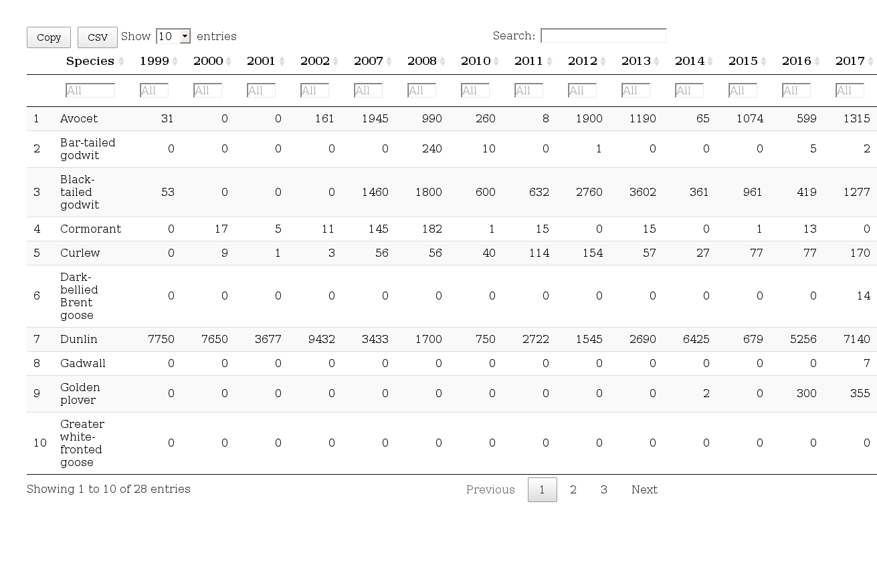

## Table of percent contribution to assemblage

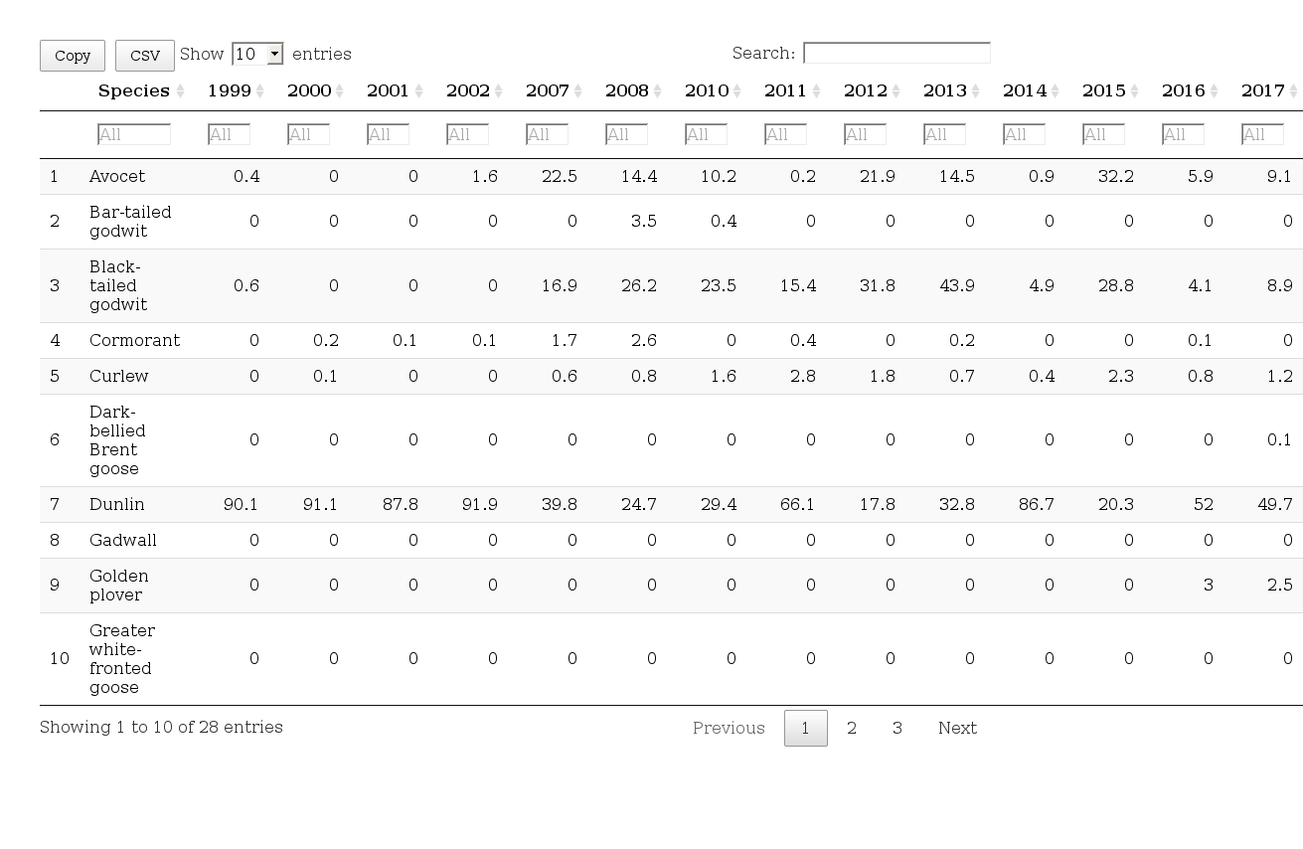

## Stacked Bar charts

Stacked bar charts show the relative contributions to the peak assemblage for the top ten most abundant species.

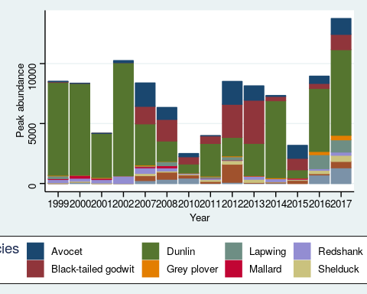

### Without Dunlin

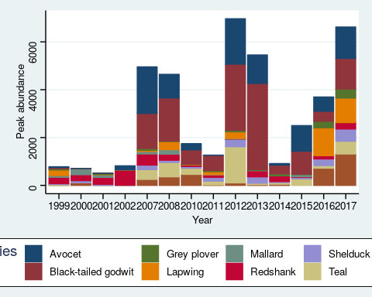

## Only top three species (Key species)

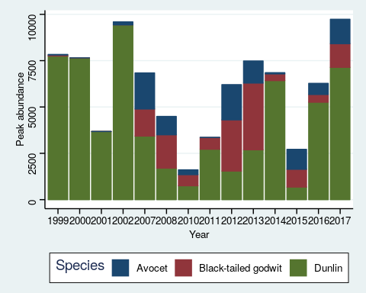

## Analysis of peak aggregation

## Regression confidence interval plots

The figure has

