JAGS non linear regression

Duncan Golicher

12/19/2018

d<-read.csv("/home/aqm/course/data/Hollings.csv")  
plot(d,pch=21,bg=2)

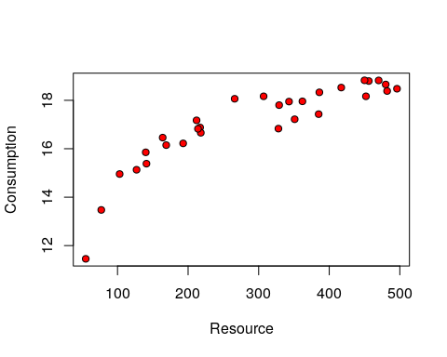

## Jags linear

library(rjags)

## Loading required package: coda

## Linked to JAGS 4.2.0

## Loaded modules: basemod,bugs

library(ggplot2)  
library(dplyr)

##   
## Attaching package: 'dplyr'

## The following objects are masked from 'package:stats':  
##   
## filter, lag

## The following objects are masked from 'package:base':  
##   
## intersect, setdiff, setequal, union

reg_mod<-"  
model{  
  
#Likelihood  
 for( i in 1:n)  
 {  
 y[i]~dnorm(mu[i], tau)  
 mu[i]<-b0+b1*x[i]  
 }  
  
#priors  
b0~dnorm(0,.01)  
b1~dnorm(0,.01)  
tau<-pow(sd, -2)  
sd~dunif(0,100)  
  
  
}"

dat<-list(n=length(d$Resource),x=d$Resource,y=d$Consumption)  
  
mod1 <- jags.model(textConnection(reg_mod), data = dat, n.chains = 3)

## Compiling model graph  
## Resolving undeclared variables  
## Allocating nodes  
## Graph information:  
## Observed stochastic nodes: 30  
## Unobserved stochastic nodes: 3  
## Total graph size: 133  
##   
## Initializing model

update(mod1, 1000)  
  
mod1_sim <- coda.samples(model = mod1, variable.names = c("b0","b1"), n.iter = 5000)  
tidybayes:::tidy_draws(mod1_sim)

## # A tibble: 15,000 x 5  
## .chain .iteration .draw b0 b1  
## <int> <int> <int> <dbl> <dbl>  
## 1 1 1 1 14.1 0.0101   
## 2 1 2 2 14.2 0.00911  
## 3 1 3 3 14.2 0.0104   
## 4 1 4 4 14.2 0.0102   
## 5 1 5 5 14.2 0.00990  
## 6 1 6 6 14.1 0.0104   
## 7 1 7 7 14.0 0.00971  
## 8 1 8 8 14.5 0.00887  
## 9 1 9 9 14.7 0.00793  
## 10 1 10 10 14.3 0.00944  
## # ... with 14,990 more rows

summary(mod1_sim)

##   
## Iterations = 2001:7000  
## Thinning interval = 1   
## Number of chains = 3   
## Sample size per chain = 5000   
##   
## 1. Empirical mean and standard deviation for each variable,  
## plus standard error of the mean:  
##   
## Mean SD Naive SE Time-series SE  
## b0 13.84704 0.378297 3.089e-03 9.779e-03  
## b1 0.01088 0.001168 9.537e-06 3.006e-05  
##   
## 2. Quantiles for each variable:  
##   
## 2.5% 25% 50% 75% 97.5%  
## b0 13.115255 13.60240 13.84360 14.09025 14.60279  
## b1 0.008541 0.01012 0.01088 0.01164 0.01315

confint(lm(Consumption~Resource,data=d))

## 2.5 % 97.5 %  
## (Intercept) 13.102428065 14.59200222  
## Resource 0.008568358 0.01318626

hyp_mod<-"  
model{  
  
#Likelihood  
 for( i in 1:n)  
 {  
 y[i]~dnorm(mu[i], tau)  
 mu[i]<-b0*x[i]/(b1+x[i])  
 }  
  
#priors  
b0~dnorm(0,.01)  
b1~dnorm(0,.01)  
tau<-pow(sd, -2)  
sd~dunif(0,100)  
  
  
}"

mod1 <- jags.model(textConnection(hyp_mod), data = dat, n.chains = 3)

## Compiling model graph  
## Resolving undeclared variables  
## Allocating nodes  
## Graph information:  
## Observed stochastic nodes: 30  
## Unobserved stochastic nodes: 3  
## Total graph size: 163  
##   
## Initializing model

update(mod1, 1000)  
  
mod1_sim <- coda.samples(model = mod1, variable.names = c("b0","b1"), n.iter = 5000)

summary(mod1_sim)

##   
## Iterations = 2001:7000  
## Thinning interval = 1   
## Number of chains = 3   
## Sample size per chain = 5000   
##   
## 1. Empirical mean and standard deviation for each variable,  
## plus standard error of the mean:  
##   
## Mean SD Naive SE Time-series SE  
## b0 19.79 0.189 0.001543 0.004894  
## b1 36.41 2.415 0.019717 0.064631  
##   
## 2. Quantiles for each variable:  
##   
## 2.5% 25% 50% 75% 97.5%  
## b0 19.42 19.67 19.80 19.92 20.16  
## b1 31.56 34.82 36.44 38.04 41.02

nlmod<-nls(Consumption~s*Resource/(F+Resource),data = d,start = list( F = 20,s=20))  
confint(nlmod)

## Waiting for profiling to be done...

## 2.5% 97.5%  
## F 33.97300 43.66697  
## s 19.58576 20.32930

## Buntings

d<-read.csv("/home/aqm/course/data/buntings.csv")  
plot(rate~density,data=d,pch=21,bg=2)

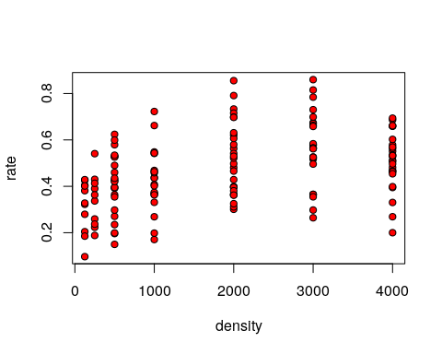

Trying to write the Bayesian model.

Use Gamma errors to avoid negative rates. Set gammas on both paprameters as priors. Use the rep-paramaterisation of gamma in terms of mean and standard deviation instead of shape and scale for clarity.

## Priors

priors<-"  
model{  
#priors  
a~dgamma( ((a_mu^2)/a_sig), (a_mu/a_sig))  
H~dgamma( ((H_mu^2)/H_sig), (H_mu/H_sig))  
sig~dunif(0.0001,1)  
  
}"  
  
dat<-list(a_mu=0.00117,a_sig= 0.0000053,H_mu=2.64950,H_sig=0.28727)  
mod1 <- jags.model(textConnection(priors), data = dat, n.chains = 5)

## Compiling model graph  
## Resolving undeclared variables  
## Allocating nodes  
## Graph information:  
## Observed stochastic nodes: 0  
## Unobserved stochastic nodes: 3  
## Total graph size: 17  
##   
## Initializing model

update(mod1, 10000)  
  
priors_mod <- coda.samples(model = mod1, variable.names = c("a","H"), n.iter = 50000)  
  
plot(priors_mod)

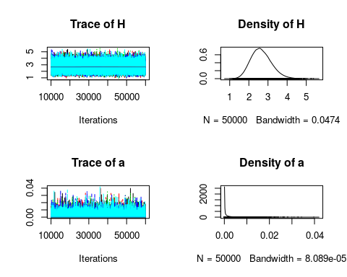

hol_mod<-"  
model{  
  
#Likelihood  
 for( i in 1:n)  
 {  
   
 y[i] ~dgamma( ((mu[i]^2)/sig), (mu[i]/sig))  
 mu[i]<- a*x[i]/(1+a*x[i]*H)  
   
 }  
  
#priors  
a~dgamma( ((a_mu^2)/a_sig), (a_mu/a_sig))  
H~dgamma( ((H_mu^2)/H_sig), (H_mu/H_sig))  
  
  
sig~dunif(0.0001,1)  
  
  
}"

The model still does not really work, even with informative priors derived from the quantile regression.

dat<-list(n=length(d$Resource),x=d$density,y=d$rate,a_mu=0.00117,a_sig= 0.0000053,H_mu=2.64950,H_sig=0.28727)  
mod1 <- jags.model(textConnection(hol_mod), data = dat, n.chains = 5)

## Compiling model graph  
## Resolving undeclared variables  
## Allocating nodes  
## Graph information:  
## Observed stochastic nodes: 0  
## Unobserved stochastic nodes: 3  
## Total graph size: 310  
##   
## Initializing model

update(mod1, 10000)  
  
mod1_sim <- coda.samples(model = mod1, variable.names = c("a","H"), n.iter = 50000)

summary(mod1_sim)

##   
## Iterations = 10001:60000  
## Thinning interval = 1   
## Number of chains = 5   
## Sample size per chain = 50000   
##   
## 1. Empirical mean and standard deviation for each variable,  
## plus standard error of the mean:  
##   
## Mean SD Naive SE Time-series SE  
## H 2.648451 0.535223 1.070e-03 1.068e-03  
## a 0.001173 0.002306 4.612e-06 4.612e-06  
##   
## 2. Quantiles for each variable:  
##   
## 2.5% 25% 50% 75% 97.5%  
## H 1.704e+00 2.270e+00 2.6135104 2.987838 3.795427  
## a 1.901e-09 1.411e-05 0.0002188 0.001246 0.007996

plot(mod1_sim)

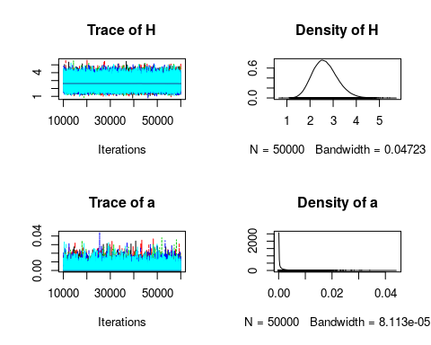

HDmod<-nls(rate~a*density/(1+a*density*H),data = d,start = list(a =0.001,H=2))   
confint(HDmod)

## Waiting for profiling to be done...

## 2.5% 97.5%  
## a 0.002593086 0.006694939  
## H 1.713495694 1.976978655