Evaluating predator prey models

Duncan Golicher

23/07/2021

## Introduction

*This document provides a guide for your project. It is not citeable material and is written in an informal style to provide advice on how to address the project. Feel free to rewrite and ideas expressed in your own words following the style of a scientific paper.*

## The Lotka Volterra predator prey model

The classic “text book” model that links the dynamics of a prey population to that of a predator population was developed by Lotka and Volterra in 1927. It is extremely simple.

$\frac{dN}{dt}=r_{1}N−αNP$

$\frac{dP}{dt}=αβNP−γP$

There are many explanations of the derivation of these equations in text books and on the internet. They can be written in several different ways, but the basic idea is always the same. I’ll explain it in simple terms here.

The $R_{1}$ parameter represents the intrinsic rate of growth of the prey population $N$ in the absence of predation. If there were no predators then the prey would increase exponentially.

The $α$ parameter controls mortality due to hunting. The loss of prey is modelled by multiplying $α$ by the number of prey and the number of predators. To understand this, think about the case when there is just one predator and 100 prey. If the predator can catch 10% of the prey (i.e. ten prey) then $α$ would be 0.1.

Once the prey are eaten they can be used to increase the predator population. The very simple model assumes that there is a conversion factor $β$ that determines how many new prey are added to the population. So if ten prey are equivalent to ten new predators then $β$ would equal 0.1

The predator population dies off through an exponential decay process modelled as $γP$. So if half the prey die each year $γ$ would equal 0.5

Although the text book treatments of these equations can give the impression of sophistication and lead to beautiful mathematical treatments, in reality the model is very unstable. It is clearly oversimplified.

1. There is no limitation to the growth of the prey population apart from predation. In other words food availability and other similar limiting factors are not included.
2. Mortality of prey **only** takes place through predation.
3. Predators only consume one form of prey. So in the absence of all prey they would become extinct.
4. The mathematical model allows fractions of individuals. So prey populations can fall below one in the model.

In fact if the simple model is implemented in R using the easy to estimate parameters as stated above it behaves like this.

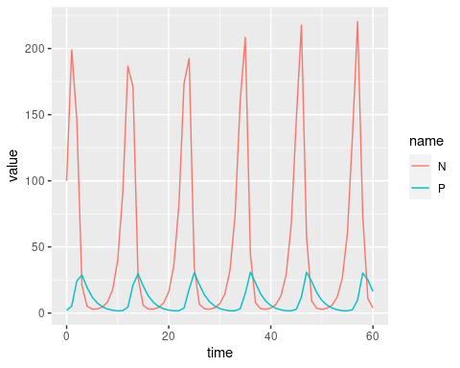

These extreme cycles can be modified by changing the parameters, but the instability and lack of realism of the model means that it is not a suitable representation of a real system. It is a mathematical toy. The classic example of rather similar cycles found in nature is the Canadian snowshoe hare and Lynx data provided by trapping records. Although this has frequently been used to justify the model closer inspection of the data led to some suspicions. In fact the cycles didn’t match the predictions at all as the peak in prey numbers occurred after the peak in predators. This led one author to suggest (tongue in cheek) that hares must eat Lynx! (Gilpin 1973).

## The Lotka Volterra model with prey carrying capacity

One element of the model that can be fixed quite easily is to assume that the prey population is controlled by some other environmental limitations. To do that we need to know the prey carrying capacity (K).

$\frac{dN}{dt}=r_{1}N(1−\frac{N}{K})−αNP$

$\frac{dP}{dt}=αβNP−γP$

Now if we run the model we get a much more boring result from the mathematical perspective.

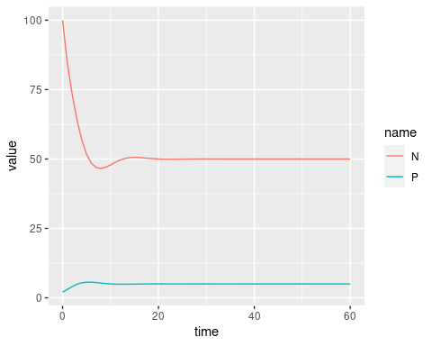 The cyclical behaviour changes into one of long term equilibria between predator and prey. However this is more useful if we are thinking about how changing an ecosystem through introducing (or reintroducing) a predator may lead to an impact though the establishment of a new equilibrium prey population which is below the carrying capacity established by food availability. This may provide opportunities for the food to be exploited by another species and may stabilise boom and bust cycles in the prey.

## Alternative prey

How can we take into consideration the possibility that the predator itself does not depend only on the prey species in order to survive? One way is to allow the predator to give birth to young without consuming the prey. Additional prey are a bonus. Consuming the prey species does add some predators, but the predator is not dependent on them. This can be quite easily added to the model.

$\frac{dN}{dt}=r_{1}N(1−\frac{N}{K})−αNP$

$\frac{dP}{dt}=r_{2}P+αβNP−γP$

A minor extension of this idea is to also add predator independent mortality of the prey species. This makes sense, as not all prey that die are consumed by the predator. This just requires adding another $γ$ parameter to the equations.

$\frac{dN}{dt}=r_{1}N(1−\frac{N}{K})−αNP−γ_{1}N$

$\frac{dP}{dt}=r_{2}P+αβNP−γ_{2}P$

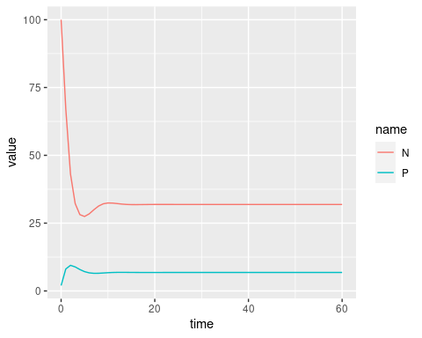

This is the essence of the model you will use for the project, expressed in mathematical terms. You can use the equations in the methods section in order to give more formality to the work. However if you don’t feel comfortable with the dry formal mathematics, don’t worry. The mathematical formulation remains very simple in essence. To develope a more expressive and intuitive model we will use the mathematics as a framework, and implement these ideas in a more expressive form using insight maker.

## References

Gilpin, Michael E. 1973. “Do Hares Eat Lynx?” *The American Naturalist* 107 (957): 727–30. <https://doi.org/10.1086/282870>.