Distance from tree line

Duncan Golicher

14/12/2021

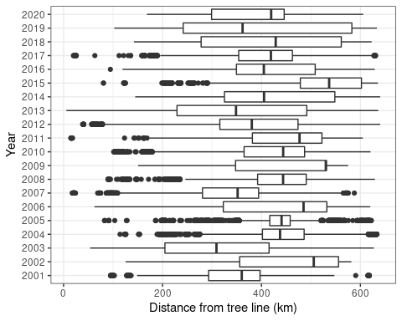

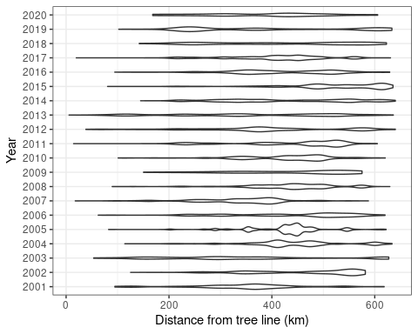

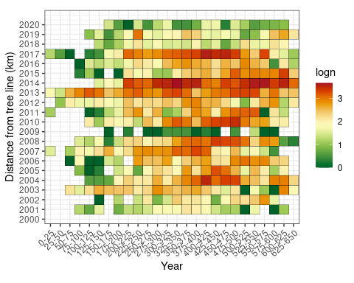

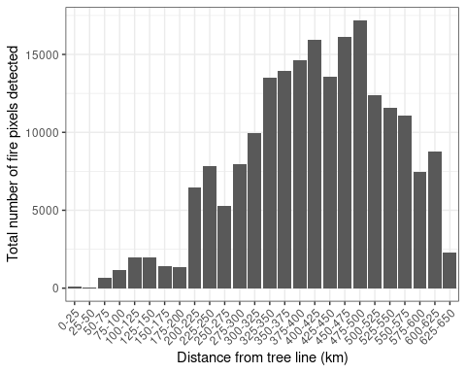

## OGR data source with driver: ESRI Shapefile   
## Source: "/tmp/Rtmp6FAaM1", layer: "ne_10m_lakes"  
## with 1355 features  
## It has 41 fields  
## Integer64 fields read as strings: scalerank ne_id

## Spherical geometry (s2) switched off

