Effect of salinity on the rate of decay of buried meat

Duncan Golicher

02/02/2022

## Methods

Data were analysed using R (R Core Team 2020). Plots and data formatting used the tidyverse package(Wickham et al. 2019). The percentage loss of weight over the time of the experiment was calculated for each piece of meat by dividing the measured weight by the starting weight, subtracting the result from 1 and multiplying by 100. Linear analysis of covariance was used to look for differences between relative weight loss associated with treatment. As the starting weights differed between experimental units an initial analysis was conducted to investigate the degree to which the initial weight could influence the results.

d %>% group_by(id) %>% mutate(percent_loss=round(100*(1-Weight/max(Weight)),1)) %>% mutate(Initial=max(Weight)) ->d

## Effect of starting weight

d %>% filter(Week>0) %>% ggplot(aes(x=Initial,y=percent_loss)) +geom_point() +geom_smooth(method="lm") +facet_wrap(~as.factor(Week)) -> g1  
g1 +labs(title="Effect of intial weight on percent loss", y="Percent weight loss", x="Initial weight")

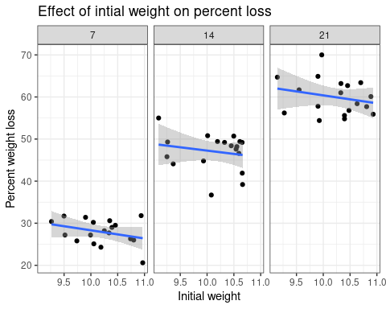

d %>% filter(Week>0) ->d1  
mod<-lm(data=d1, percent_loss~as.factor(Week)+Initial)  
anova(mod)

## Analysis of Variance Table  
##   
## Response: percent_loss  
## Df Sum Sq Mean Sq F value Pr(>F)   
## as.factor(Week) 2 9338.3 4669.1 312.7034 < 2e-16 ***  
## Initial 1 44.8 44.8 3.0029 0.08928 .   
## Residuals 50 746.6 14.9   
## ---  
## Signif. codes: 0 '***' 0.001 '**' 0.01 '*' 0.05 '.' 0.1 ' ' 1

The analysis showed a very slight negative effect of starting weight on relative weight loss, which was most notable after week 7. However this was not statistically significant and so would have a negligible impact on further analysis F=3(1,50) p=0.09.

## Effect of treatment and time on weight loss

d %>% ggplot(aes(x=Week,y=percent_loss, col=Treatment)) +geom_point() +geom_smooth(method="lm") +facet_wrap("Treatment") -> g1  
g1 +labs(title="Percentage loss in weight over time for each treatment", y="Percent weight loss", x="Week")

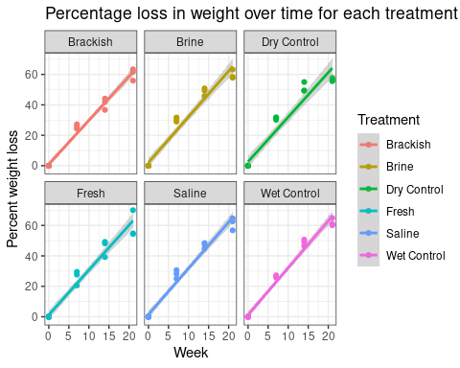

This analysis of covariance asked whether there is any statistically significant difference in the slopes of the lines that represent the decline in weight over time that could be attributed to the treatments. Mean differences in relative weight loss were assessed as the intercept in a model including interactions. The interaction assessed whether slopes differed between treatments.

mod<-lm(data=d,percent_loss~Week*Treatment)  
anova(mod)

## Analysis of Variance Table  
##   
## Response: percent_loss  
## Df Sum Sq Mean Sq F value Pr(>F)   
## Week 1 62704 62704 3088.8123 <2e-16 ***  
## Treatment 5 57 11 0.5607 0.7299   
## Week:Treatment 5 32 6 0.3113 0.9051   
## Residuals 96 1949 20   
## ---  
## Signif. codes: 0 '***' 0.001 '**' 0.01 '*' 0.05 '.' 0.1 ' ' 1

The analysis of covariance provided no evidence of any differences between treatments in overall weight loss expressed as a percentage of the initial weight. F=0.56(5,96), p=0.73. There was no evidence of differences between slopes of the lines F=0.3(5,96) p=0.7.

A further breakdown shows that none of the treatments differed from the brackish treatment, which was here regarded as the reference due to being in the mid range of the treatments. The significant effect of time is an expected result and no consideration is made of its statistical significance. You can state that the rate of loss was approximately linear with respect to time, with a constant loss of 2.9% of the initial weight each week.

summary(mod)

##   
## Call:  
## lm(formula = percent_loss ~ Week * Treatment, data = d)  
##   
## Residuals:  
## Min 1Q Median 3Q Max   
## -8.717 -2.106 -1.242 2.972 11.326   
##   
## Coefficients:  
## Estimate Std. Error t value Pr(>|t|)   
## (Intercept) 0.98194 1.40487 0.699 0.486   
## Week 2.88512 0.13139 21.959 <2e-16 ***  
## TreatmentBrine 1.12361 1.98678 0.566 0.573   
## TreatmentDry Control 1.63333 1.98678 0.822 0.413   
## TreatmentFresh 0.25972 1.98678 0.131 0.896   
## TreatmentSaline 0.51806 1.98678 0.261 0.795   
## TreatmentWet Control 0.29167 1.98678 0.147 0.884   
## Week:TreatmentBrine 0.11964 0.18581 0.644 0.521   
## Week:TreatmentDry Control 0.04762 0.18581 0.256 0.798   
## Week:TreatmentFresh 0.06131 0.18581 0.330 0.742   
## Week:TreatmentSaline 0.14583 0.18581 0.785 0.434   
## Week:TreatmentWet Control 0.20119 0.18581 1.083 0.282   
## ---  
## Signif. codes: 0 '***' 0.001 '**' 0.01 '*' 0.05 '.' 0.1 ' ' 1  
##   
## Residual standard error: 4.506 on 96 degrees of freedom  
## Multiple R-squared: 0.9699, Adjusted R-squared: 0.9664   
## F-statistic: 281.2 on 11 and 96 DF, p-value: < 2.2e-16

# References

R Core Team. 2020. *R: A Language and Environment for Statistical Computing*. Vienna, Austria: R Foundation for Statistical Computing. <https://www.R-project.org/>.

Wickham, Hadley, Mara Averick, Jennifer Bryan, Winston Chang, Lucy D’Agostino McGowan, Romain François, Garrett Grolemund, et al. 2019. “Welcome to the tidyverse.” *Journal of Open Source Software* 4 (43): 1686. <https://doi.org/10.21105/joss.01686>.